|  |
| --- |
| Lean Startups – Scratch Book |
| BidWise |
| It’s a faster, simpler, and smarter way to trade debt. |

|  |
| --- |
| Jarmo Tahvanainen Eppu Hassinen Risto Teerikoski |
| 10-30-2024 |

Contents

1. INTRODUCTION 6

1.1. Purpose and Vision 6

1.2. Key Objectives 6

1.3. About Us 7

1.4. Approach and Methodology 8

2. WEEK 1: BUSINESS IDEA PITCH 9

2.1. How it all began 9

2.2. Early ideas for BidWise 9

2.3. Exploring NPL Market challenges and opportunities 12

2.4. Rolling around the idea 12

2.4.1. Use of PMI for validating the idea 12

2.5. Creating the first pitch 14

2.5.1. Objective of the Pitch 15

2.5.2. Research and Preparation 15

2.5.3. Developing the Pitch Content 16

2.5.4. Finalizing the Pitch 16

2.5.5. Practice and Presentation 16

2.6. Key learning and reflections 17

3. WEEK 2: BUSINESS MODEL CANVAS 18

3.1. Our team: introduction 18

3.2. Defining roles and responsibilities 19

3.3. Idea validation 20

3.3.1. Interview with a NPL seller 23

3.3.2. Interview with a small NPL investor 23

3.4. Our first Business Model and Value Proposition Canvases 23

3.5. Meeting 04.11.2024: Refining the business idea 26

3.6. Pitch for AI-Driven NPL Market platform 26

3.6.1. Reflections about learning 26

3.6.2. Jarmo’s reflection 26

3.6.3. Risto’s reflection 27

3.6.4. Eppu’s reflection 27

4. WEEK 3: VALIDATION 28

4.1. TASK: Value Your Business Idea 28

4.1.1. Does your idea solve a significant problem? 28

4.2. Business Model Canvas 30

4.3. Jarmo’s notes and ideas from the 11.11.2024 lecture 32

4.4. Identifying potential customers 33

4.5. Questions for Customers (Debt Sellers and Purchasers): 34

4.6. Questions for Potential Partners: 35

4.7. Customer validation 36

4.7.1. KTI-Perintä 36

4.7.2. S Finance 38

4.8. Research on the NPL market and trends 39

4.9. Benchmarking similar business models 41

4.10. Reflections about learning 41

4.10.1. Jarmo’s reflection 41

4.10.2. Risto’s reflection 42

4.10.3. Eppu’s reflection 44

4.11. Market validation and location-specific research 45

4.11.1. Scoping out potential market segments 45

4.11.2. Starting market and expansion markets 45

4.11.3. Analysis of existing NPL platforms 46

4.12. Pitch version 3 47

5. WEEK 4: MVP 49

5.1. Insights from the 18.11.2024 lecture 49

5.2. MVP development 49

5.3. Reflections about learning 50

5.3.1. Jarmo’s reflection 50

5.3.2. Risto’s reflection 51

5.3.3. Eppu’s reflection 52

5.4. Pitch version 4 52

5.5. Customer validation 54

6. WEEK 5: METRICS 58

6.1. Thoughts on lecture 25.11.2024 58

6.2. Defining key metrics for BidWise 59

6.2.1. User engagement metrics 59

6.2.2. Financial performance indicators 59

6.3. Reflections about learning 61

6.3.1. Jarmo’s reflection 61

6.3.2. Risto’s reflection 61

6.3.3. Eppu’s reflection 62

6.4. Pricing model development 62

7. WEEK 6 64

7.1. Thoughts on lecture 02.12.2024 64

7.2. Financial calculations and projections 65

7.3. Video planning 69

7.3.1. First draft of the video script 70

8. WEEK 7: THE RIOT 71

8.1. Preparing the final video 71

8.1.1. Video narration 72

8.2. Final pitch presentation 73

8.3. Final reflections about learning 78

8.3.1. Jarmo’s reflection 78

8.3.2. Risto’s reflection 79

8.3.3. Eppu’s reflection 79

9. SUMMARY 80

10. REFERENCES 82

11. Idea Storage: 83

11.1. Questions to customers and partners (in Finnish) 83

12. Additional Stuff 87

12.1. Funding 87

12.2. Yearly needed funding 88

12.3. Revenue expectations 91

13. Logo development 94

14. Name development 95

# INTRODUCTION

This Scratch Book documents our startup journey with BidWise, a digital marketplace that connects small businesses and investors for buying and selling non-performing loans (NPLs). Our team – Jarmo Tahvanainen, Risto Teerikoski, and Eppu Hassinen – aims to address the unique challenges that smaller companies and NPL investors face in the NPL market. Through AI-driven valuation, analytics, and insights, we seek to create a more accessible and efficient platform for NPL transactions.

## Purpose and Vision

BidWise was created with the vision of opening up access to the NPL market, providing small businesses a platform to sell their non-performing receivables (NPLs). By combining AI technology with a user-friendly marketplace, we aim to make the process more accessible, transparent, and efficient for both NPL sellers and buyers. BidWise provides organizations a genuine possibility to sell their suppliers’ debts without binding themselves to expensive and time-consuming agreements with debt collectors. Instead, organizations can sell the credits desired to the platform’s bid prize. It also provides organizations with existing credit collection partnerships to find alternative ways and prices for credit collecting and thus gives the possibility to benchmark the current procedures.

## Key Objectives

This project will follow our journey from ideation to pitch, highlighting each phase of the development process, from creating our initial business model to validating market needs. It also includes weekly reflections on our learning and adaptation, capturing both our accomplishments and challenges. The Scratch book will function as a learning diary in our project, including all phases of the project from the very first thoughts of the project to the final product that is to be presented in the course. By completing this project, not only the learning requirements of the course are met, but the group members will have created a product the hopefully will become a functioning business idea that can be built in real life.

The objective of the project outcome is to make credit collection easier and more accessible to all kinds of organizations, without unnecessary costs or administrative burden. BidWise adds value by providing an opportunity with guaranteed, instantly paid price, enabling all organizations to secure an amount of the arisen debts.

## About Us

Our team brings together diverse skills in business development, AI technology, and market analysis, positioning us well to tackle the NPL market. We are passionate about empowering smaller businesses and are motivated by a shared vision to bring transparency and efficiency to financial transactions in this space.

Jarmo Tahvanainen is currently studying for a master’s in management and information technology, focusing on software engineering management at Tampere University’s Pori campus. Based in Lohja, Finland, Jarmo is diving into the world of software development and project management, learning how to connect tech skills with business know-how.

Eppu Hassinen is a 4th year student in Tampere University majoring in embedded systems and minoring in software business. He has also knowledge in robotics and machine learning.

Risto Teerikoski is a master’s degree student in Industrial Management from Tampere University, Pori campus. Risto is physically located on Åland Islands, Finland.

This group of four wannabe experts is on a route to delve into (pun intended) the realm of startups. But seriously, we see a great potential in this business idea and are more than happy to proceed with this is we somehow find the needed multimillion investment.

Our main mission? To dig into every exciting piece of building a scalable startup—brainstorming big ideas, fine-tuning the details, and figuring out what it really takes to make things fly. And yeah, we’d also like to pass the course, which should be a breeze if we nail the fun stuff first!

## Approach and Methodology

We employ a lean startup methodology, using iterative processes to validate our concept, gather customer feedback, and refine our value proposition. Core tools include business model canvas for mapping and refining our business model, customer interviews and surveys to gain insights into the needs of small business owners and investors, competitive and SWOT analysis to identify our strengths, weaknesses, and market opportunities and PMI (Plus, Minus, Interesting) model to evaluate ideas and adapt quickly.

# WEEK 1: BUSINESS IDEA PITCH

## How it all began

The group was formed by the course teacher, after which the team members got in touch with one another through email. On Wednesday, October 30th, the group gathered for a first Teams meeting, where the group forming process started by introductions, short presentations and brainstorming of the ideas that the group members had. After short presentations, the team discovered that all of them were studying at Tampere university and that distance studies would be the best method to work further. There were two ideas on the table, of which the group decided to choose the concept of BidWise. The reason for choosing BidWise upon the other concept was that the group saw huge potential in implementing the BidWise solution to an actual business.

## Early ideas for BidWise

When the team gathered on the Team for the first time, the participants presented their ideas. Risto presented his idea of a mobile application, in which the user can record his or her fish catches. The business idea was to gain revenue from advertising costs, member fees and from collect fishing data that can be sold to the fishing authorities in different countries. The group liked the idea of having this as a use case for the course but was more eager on implementing the second idea presented. The second idea was presented by Jarmo, who presented a concept of a platform for trading non-performing loans. The business idea for the platform would be a percentage of the fees paid per transaction, but additional income strategies were also discussed.

The team decided to focus on the idea of non-performing loans (NPL’s). An NPL is a commonly used phrase for referring to all kinds of non-performing receivables, like unpaid invoices. The team had initial discussions about the idea of the NPL market in Finland. Our team member Jarmo has vast experience within the field, where he, among other things, has been working for one of the major debt-collecting agencies. Jarmo described how the debt-collecting process normally goes: the agencies can have agreements with organisations regarding debt-collection, or they source organisations who potentially have big portfolios. The initial idea was therefore to create a platform, in which smaller B2C-selling organizations can sell their non-performing invoices and where the investors can buy these. The reason why this kind of a platform is needed is because it enables businesses to sell their NPL: s straight away instead of waiting for debtors to pay their invoices. Selling the receivables is quite a new phenomenon, because they have historically been handled by debt-collecting agencies as organizations’ own debts. However, by selling receivables, a business can liquidate their non-performing receivables and use that money more useful. Additionally, for smaller businesses, this is a splendid way to establish cost-efficient credit management processes.

Debt-purchasing companies are very interested in purchasing debts from smaller companies. This platform works as an NPL market for smaller business and connects sellers and purchasers.

In addition to being a yet non-existing platform for small and medium-sized debt transactions, the competitive advantage is gained by price-knowledge objectivity. The system is empowered with artificial intelligence, which determines a fair value for the portfolios that organizations aim to sell. The price estimation comes from historic values, that are either gained from cooperative partners that are invited to be the partners with whom the platform is set up to its initial phase. When trades start running, the artificial intelligence platform will gain new data from the platform and utilize it for future trades.

The aim of creating such a platform is not only to enable smaller actors to the market and to find more competitive and transparent trading. The main objective is to revolutionise by introducing NPL-trading to the new normal way of trading.

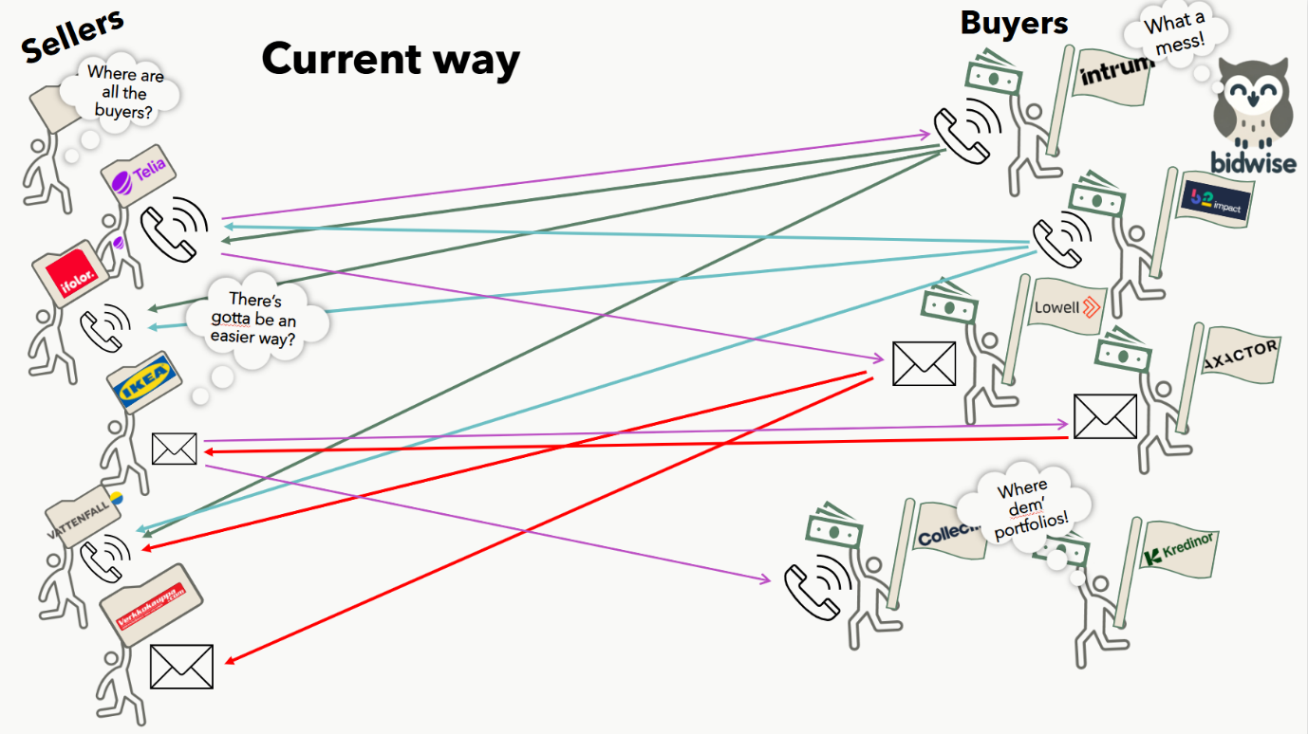Figure 1: Current way of trading debt.

Instead of contacting customers, debt-collection agencies can follow the NPL-market and access a whole lot of NPLs while saving the salary costs for Key Account Manager.

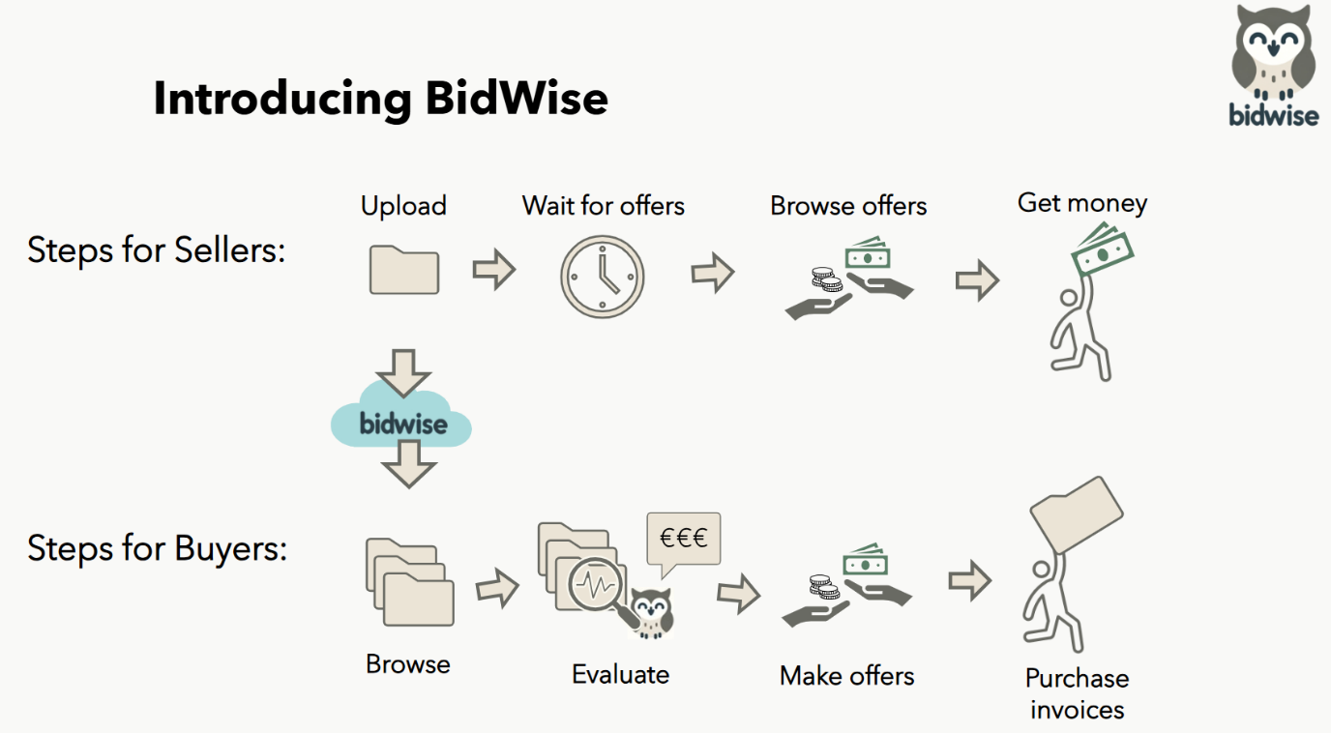Figure 2: The new way of trading debt.

* + - Might have bigger affection to the whole credit management industry
    - Idea is suitable for a startup
      * Scalable
  + Consideration of idea assessment tools. We chose to use these:
    - Modern/light version of the traditional evaluation
    - A quick evaluation model presented in the lecture slides.
    - PMI (Plus, Minus, Interesting) model

## Rolling around the idea

### Use of PMI for validating the idea

PMI (Plus, Minus, Interesting) is a decision-making tool that helps evaluate the positives, negatives, and interesting aspects of an idea.

**Plus**

1. BidWise solvea a real market need. It simplifies the process of buying and selling non-performing loans (NPLs), giving sellers faster cash flow and buyers valuable portfolio options.
2. With AI-driven efficiency, BidWise can, through automated valuations and recommendations, provide fair pricing, saving time and reducing risk for both sides.
3. The revenue model is scalable, both nation-wide and internationally, because that revenue model is based upon a transaction-fee model and subscription model.
4. Unique Market Positioning: Targets small and mid-sized NPL sellers with smaller NPL portfolios, an underserved niche with a huge growth potential.

**Minus**

1. Compliance challenges: Strict financial regulations mean high initial costs for ensuring legal and data security standards. Mitigate by investing in an in-house or outsourced compliance professional.
2. Risk for high development costs: Building a secure, AI-powered platform requires significant investment in technology and expertise. Mitigate by starting with simpler AI models.
3. Trust-building in the market is crucial for success. BidWise will need to build trust around AI valuations and data security for users to feel comfortable. Mitigate by partnering with debt collection agencies until the trust is build up to the necessary level.
4. The business model is limited to B2C Receivables: This solution is primarily suited for B2C receivables, because company insolvency mainly means a high risk for the company going bankrupt. Therefore, it may not meet the needs of companies with B2B customers.

**Interesting aspects**

1. Data-driven advantage: AI models can provide predictive insights, setting BidWise apart in NPL analytics. BidWise can build own models and sell those.
2. Disruption potential: Decreases the need for the traditional debt collection services when there are no debts to collect once they are sold. Replaces Regarding the traditional NPL selling/purchasing process and a lot of manual work with a transparent, automated marketplace. BidWise can become as a major part of companies’ credit management processes.
3. Expansion potential: By start with smaller sellers and NPL portfolios, there is time to expand to larger sellers and portfolios and other markets over time.

## Creating the first pitch

**Initial pitch**:

"Hi, I’m [Your Name], and I’m excited to tell you about BidWise. It’s an online marketplace that helps businesses quickly sell their unpaid debts (or open invoices if you like) and lets investors easily find good deals to buy.

Right now, selling these debts is slow and expensive for companies, and investors spend a lot of time hunting for the right opportunities. BidWise changes this. Our platform uses AI to instantly assess the value and risk of each debt portfolio, giving sellers fair prices and showing investors which options are a good fit for them.

With BidWise, companies get faster cash flow, and investors have a smart, easy way to find valuable portfolios—all in one place. **It’s a faster, simpler, and smarter way to trade debt.**"

**Second pitch**:

Hi, my name is [Your name].

Imagine this. You have a business with a lot of consumers as customers, so b2c business, for example a small newly fintech offering consumer loans.

What will you do when a great amount of your customers does not pay the loans you have granted to them?

You might try to contact them directly or use a debt collection agency to recover what is yours. Some of the customers pay back nicely, but some simply cannot pay you now and you will need to WAIT possibly forever. What will you do? You cannot do much.

What if we say you could have a possibility to get the market value of the debts with an easy and fast way? Would you consider this as the best option?

### Objective of the Pitch

The objective of the pitch is to show the value of the BidWise, which is connecting small NPL sellers to NPL buyers with an online platform, so that the selling is faster, easier and cheaper for both. Platform is also powered by AI.

### Research and Preparation

TODO:

Watch a couple of good pitched from Youtube and consider why they are good and what to we should learn from them.

What a good pitch answer to?

* Addresses a problem and gives and answer (solution) to that.
* Also gives a few points why this is the correct solution, so called unique selling points. In our case it might be
  + ai analytics,
  + risk assessment tools,
  + pricing for the seller,
  + transparent bidding system.

The pitch should be understandable and short 1-3 minutes. Speech should be slow, but not too slow. Keep pauses in important parts to let the information sink in. Have a good start and ending.

### Developing the Pitch Content

#### Parts of the pitch:

**Introduction**

A warm, quick intro that sets a positive tone and introduces BidWise as a game-changer in debt trading.

**Problem**

Explains the current issues: selling debts is slow and costly for companies, while investors struggle to find good deals easily.

**Solution**

Shows how BidWise changes this with a marketplace where businesses can sell debts quickly and investors can find valuable portfolios.

**The Role of AI**

Highlights the AI-powered part**:** AI assesses value and risk instantly, giving fair prices to sellers and relevant options to investors.

**Benefits**

Summarizes the benefits: faster cash flow for businesses, smart investment options for investors, all in one easy-to-use place.

**Closing**

Ends with a tagline that reinforces BidWise as faster, simpler, smarter for trading debt, making the pitch memorable.

### Practice and Presentation

The team has practiced the pitch by taking turns in presenting it. In addition to this, the team been planning the contents of the pitch and the order in which everything will be presented carefully.

## Key learning and reflections

The first week was all about getting started with idea of BidWise and learning the basics of pitching. We realized how important it is to keep the idea simple and easy to understand, especially for people unfamiliar with the industry.

Practicing the pitch taught us that preparation is key, and every part of the presentation needs to flow well. Watching examples of great pitches gave us ideas on how to improve ours.

Using tools like PMI helped us evaluate the strengths and challenges of our idea and refine it further. Overall, it was a productive start, and we’re excited to keep building on this foundation.

# WEEK 2: BUSINESS MODEL CANVAS

## Our team: introduction

Our team at BidWise forms up of three founding members, each bringing essential skills to launch and grow the platform.

**Eppu Hassinen**, CTO, Technical and Data Lead



* + **Background**: With a strong background in software engineering and data science, Eppu leads the technical technology implementation process and AI-driven features at BidWise.
  + **Role Focus**: Eppu manages the development of AI tools for valuation and risk assessment, creating a reliable and data-backed platform that benefits both sellers and investors. He is also the main technical advisor in what can be done with the technology available today.

**Jarmo Tahvanainen**, CEO, Operations and Strategy Lead



* + **Background**: Jarmo combines financial services know-how with strategic planning and hands-on operational skills, plus a solid grasp of regulatory needs. His background in credit management and business development and sales is a perfect fit for shaping BidWise’s operations. Bringing strong leadership and a data-driven approach to decision-making, Jarmo ensures everything runs smoothly and stays aligned with our big-picture goals.
  + **Role Focus**: Jarmo defines operational processes, sets strategic goals, and ensures efficient, goal-oriented operations across the team, aligning the platform’s development with business objectives.

**Risto Teerikoski**, CFO, Business Development and Partnerships Lead



* + **Background**: Risto’s expertise in investment negotiations, business development and project management are driving factors for BidWise’s early client relationships and partnerships. Risto is also responsible for the expansion planning and execution.
  + **Role Focus**: Risto is responsible for expanding BidWise’s reach, establishing partnerships, and ensuring the platform aligns with the needs of both businesses and investors.

Together, we’re building a platform that transforms the NPL market with smart, user-friendly technology tailored to our clients’ needs.

## Defining roles and responsibilities

**Technical and Data Lead / CTO**

* Responsibilities: Developing and maintaining BidWise’s core AI models for valuation, risk assessment, and recommendations. This role involves selecting and refining AI algorithms, managing data pipelines, and ensuring the platform’s backend is robust and scalable.
* Responsible person: Eppu

**Operations and Strategy Lead / CEO**

* Responsibilities: Defining and managing operational workflows, strategic direction, and initial market positioning for BidWise. This role is focused on setting up smooth processes, coordinating between teams, and establishing clear goals and metrics for the company’s success.
* Responsible person: Jarmo

**Business Development and Partnerships Lead / CFO**

* Responsibilities: Building relationships with potential clients, investors, and strategic partners, and driving user acquisition. This role is essential for promoting BidWise to key stakeholders, developing partnerships, and understanding client needs for ongoing growth.
* Responsible person: Risto

**Product Development**

* Responsibilities: Overseeing the design and development of the BidWise platform, ensuring a user-friendly and intuitive interface for both sellers and investors. This role involves working closely with the technical team to define features, prioritize tasks, and continuously improve the platform.
* Responsible person: All

## Idea validation

To validate BidWise’s idea, it is important to interview sellers and purchasers of overdue receivables. Here’s a breakdown of potential interviewees and targeted questions for each:

* 1. Small NPL Seller (e.g., smaller companies with overdue receivables)
* **Potential Interviewees**: Small business owners, financial managers, or accountants in industries like retail, telecom, healthcare, or utilities.
* Questions:
  + How do you currently handle unpaid receivables? What challenges do you face?
  + How long does it typically take to sell an NPL portfolio, and what costs are involved?
  + Would you consider using an online platform to sell NPLs? Why or why not?
  + What would make an NPL marketplace valuable for you? (e.g., faster sales, fair pricing, easy access to buyers)
  + How important is automated pricing and risk assessment for you?
* 2. Large Seller (e.g., telecom companies, banks)
* **Potential Interviewees**: Financial executives, credit managers, or debt portfolio managers in large firms.
* Questions:
  + How do you assess potential buyers and price your NPL portfolios?
  + What pain points exist in your current process for selling large NPL portfolios?
  + How open would you be to using an AI-powered platform for faster transactions?
  + What features would make you feel secure using an online marketplace (e.g., risk assessment, confidentiality, compliance tools)?
  + What value do you place on real-time market insights and buyer recommendations?
* 3. Small Buyer (e.g., individual investors, smaller debt collection firms)
* **Potential Interviewees**: Individual investors or managers in smaller debt collection agencies.
* Questions:
  + How do you currently find and evaluate NPL portfolios to buy?
  + What are your main challenges when investing in NPLs (e.g., limited market access, difficulty in assessing value)?
  + Would access to a broader selection of NPLs and AI-driven insights influence your purchasing decisions?
  + How valuable would a recommendation engine be to streamline your search?
  + What subscription or fee models would be most appealing?
* 4. Large Buyer (e.g., investment funds, large debt collection firms)
* **Potential Interviewees**: Portfolio managers, fund managers, or executives at large debt purchasing companies.
* Questions:
  + How do you currently source high-value NPL portfolios?
  + What do you consider most critical in the valuation and risk assessment of NPLs?
  + How would automated portfolio recommendations impact your buying process?
  + What level of data security, compliance, and confidentiality would you need to use an online marketplace?
  + How do you typically budget for transaction or subscription fees?

### Interview with a seller

* Choose a random company with decent amount of unpaid b2c invoices.
* Call
* Ask the questions
* Write down thoughts from the interviewee.

### Interview with a small NPL investor

* Choose a company. Maybe a smaller debt collection agency, like Perintäritari?
* Call
* Write down thoughts from the interviewee

## Our first Business Model and Value Proposition Canvases

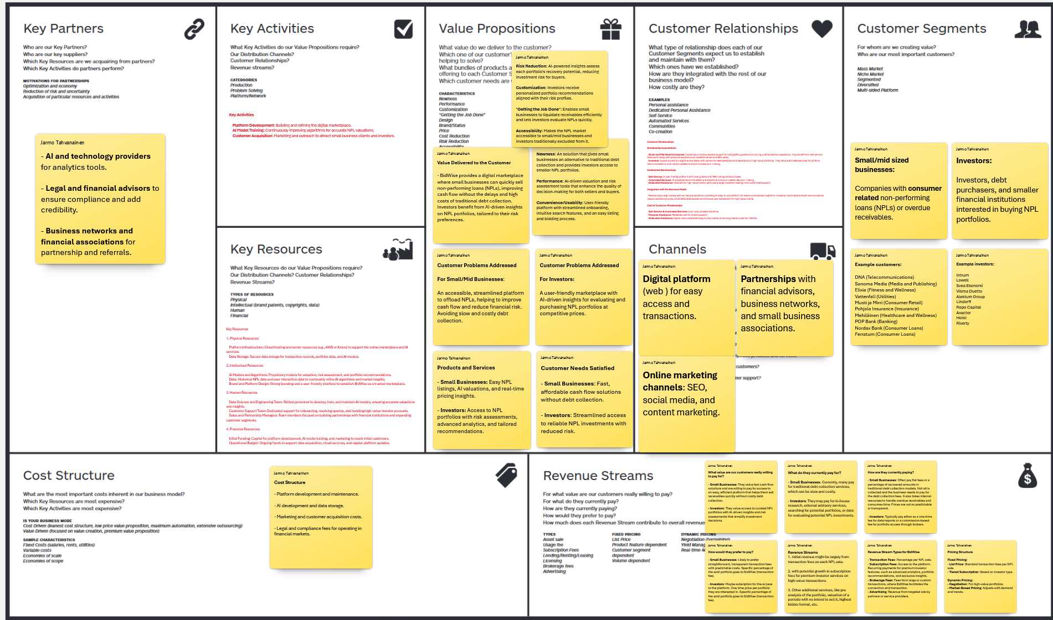

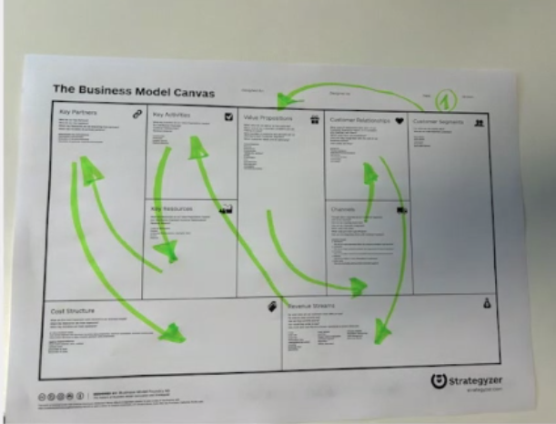

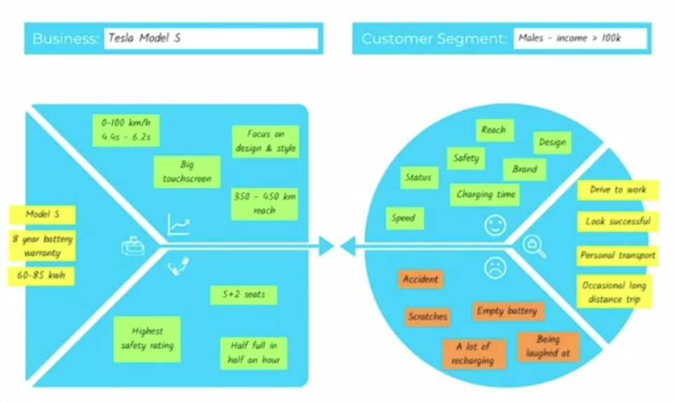

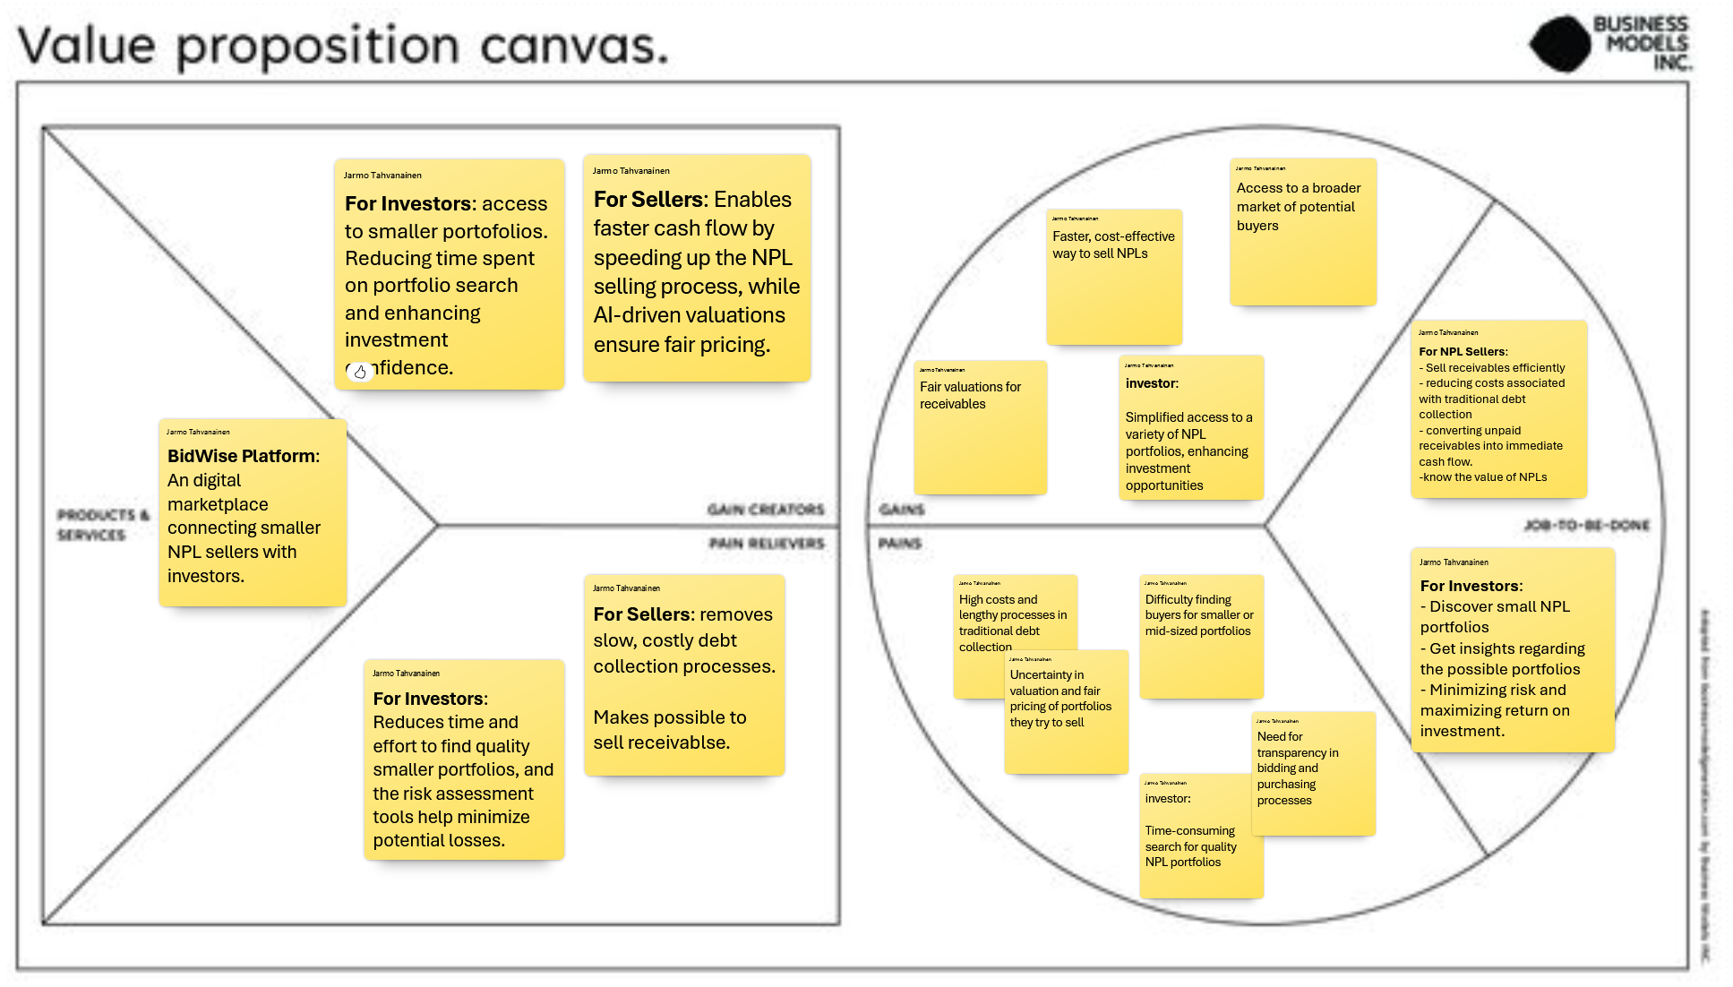

BidWise connects buyers and sellers in a digital marketplace for overdue receivables. The platform simplifies trading by using AI to ensure efficiency.

For buyers, BidWise offers quick access to smaller portfolios of overdue receivables with AI-driven insights and risk assessments. This saves time, reduces effort, and builds confidence in purchasing decisions.

For sellers, the platform provides a fast and affordable way to convert overdue receivables into cash. It replaces slow, costly debt collection with AI-based fair pricing and access to a broader buyer network.

As a team, we gained a better understanding of the market dynamics and how our solution can fit the market. It took some time to think through the value proposition chain from jobs to be done to our product and back and forth. But this was beneficial and now the whole team has a better and common understanding of our idea. With this task we also were able to focus on core things BidWise should focus, like making complex easy and to consume less time than the current way of selling and buying of receivables. This was a valuable step in validating our idea and shaping the platform to meet real needs better.

## Meeting 04.11.2024: Refining the business idea

In our business idea brainstorming, we mainly focused on how the platform should look like from the customer’s perspective and how the trades should be done in practice. We agreed on that the revenue model would be transaction-based and that it potentially also should have a subscription model.

## Pitch for AI-Driven NPL Market platform

Our pitch in Hackathon was overly long and not very informative. Our pitcher needed to leave right before our presentation, and we needed to make a quick change. Time management was perhaps the key takeaway from the pitch, since the first time it was pitched, it took about ten minutes to present.

### Reflections about learning

The hackathon was a very educative experience. This was the very first touch to pitching in the course and drew the starting line to the race towards the final pitching moment. Frederic Pattyn and Mario Simaremare both seemed to be very profound experts in the startup segment. Frederic has a very interesting background as a successful startup entrepreneur and Mario has a solid background as a researcher within the field.

### Jarmo’s reflection

The hackathon was a good learning experience. It showed how important it is to prepare well and keep the pitch simple and clear. Our initial pitch didn’t go as planned because of last-minute changes, and it taught me how everyone in the team needs to be ready to step in.

I realized that too much information can confuse people, and it’s better to focus on the main idea and use clear numbers. Listening to the experts gave great tips that we can use to improve. Overall, it was a useful experience for our next pitch.

### Risto’s reflection

I was looking forward to pitching BidWise to the audience, but I had to leave at 15:45 (I was at work) and I saw that the earlier teams’ pitches stretched out more and more and the timetable was getting more and more narrow for the pitch. The team before us started at 15:40, leaving no time for me to pitch. Luckily, Eppu was able to take over the pitching. Until this, however, it was valuable to listen to the experts giving their opinions about the other teams’ business ideas.

### Eppu’s reflection

I was the pitcher when Risto needed to leave when the presentations before us were longer than expected. The pitching was hard, and it did not go well in my opinion. I did not know much about what to say. We should have had more numbers and less complex sentences. One needs to have the idea and business model clear in their mind to be able to pitch it

# WEEK 3: VALIDATION

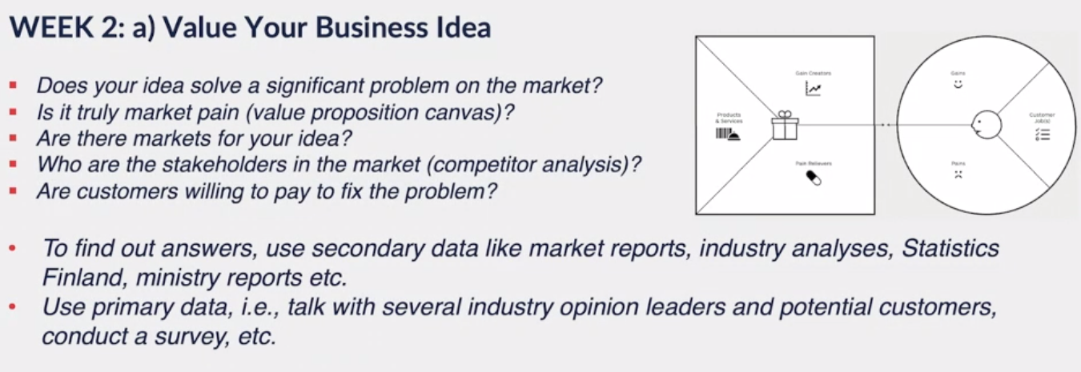

## TASK: Value Your Business Idea

### Does your idea solve a significant problem?

#### Significant problems:

* Difficulty for small and mid-sized companies to sell NPLs: Small and mid-sized businesses often face challenges in selling their non-performing loans (NPLs) due to limited access to buyers and platforms. Our idea provides a streamlined and open platform specifically designed for these smaller NPL portfolios, enabling these businesses to sell their unpaid receivables more efficiently.
* Slow and costly NPL transactions for both sellers and investors: Selling NPL portfolios through traditional methods is both time-consuming and costly. Our platform simplifies this process, making it less expensive for sellers and investors alike. Smaller companies benefit by having an alternative to costly debt collection processes, and investors gain access to more portfolios without needing to search for sellers independently, offering a faster and cheaper way of acquiring portfolios.

#### Is it truly market pain? (Value Proposition Canvas)

* Yes, this is a genuine market pain. For sellers, traditional debt collection is expensive and slow, with few options to sell NPLs directly. For investors, finding quality NPL portfolios is resource-intensive, and they often lack data-driven insights for risk assessment and valuation. BidWise addresses these pains by creating a transparent marketplace where portfolios are pre-checked, ensuring data reliability.
* Validation needed:
  + Sellers: Engage with both small/mid-sized sellers who have sold NPLs before and those who have not.
  + Investors: Get feedback from smaller investors, like Suomen Perintäritari or KTI-Perintä

#### Are there markets for your idea?

* Preliminary insights suggest there is a market for this idea. Additional research is necessary to confirm the needs and demand among small and mid-sized businesses.

#### Who are the stakeholders in the market? (Competitor Analysis)

* The primary stakeholders in the NPL market include debt collection agencies, NPL trading platforms, small and mid-sized sellers, investors, and regulatory authorities overseeing debt and data privacy laws.

#### Are customers willing to pay to fix the problem?

* Businesses that struggle with low NPL quantities are likely willing to pay for an affordable option that minimizes risk and maintains their cash flow. By providing a tailored solution, BidWise offers a valuable alternative for these customers.

#### To find out answers, use secondary data like market reports, industry analyses, Statistics Finland, ministry reports etc.

* By the end of 2024, there were 259 135 debtors under enforcement in Finland. 91 per cent of these were physical persons. In total, their enforced debt to a total of 7,3 billion euros. During 2023, there were 573 798 debtors under enforcement, which means that in 55 cases, the pendency of the debtors ended already in 2023 (<https://stat.fi/julkaisu/clmiusxvt4ymj0avvowu81pi5>).

## Business Model Canvas

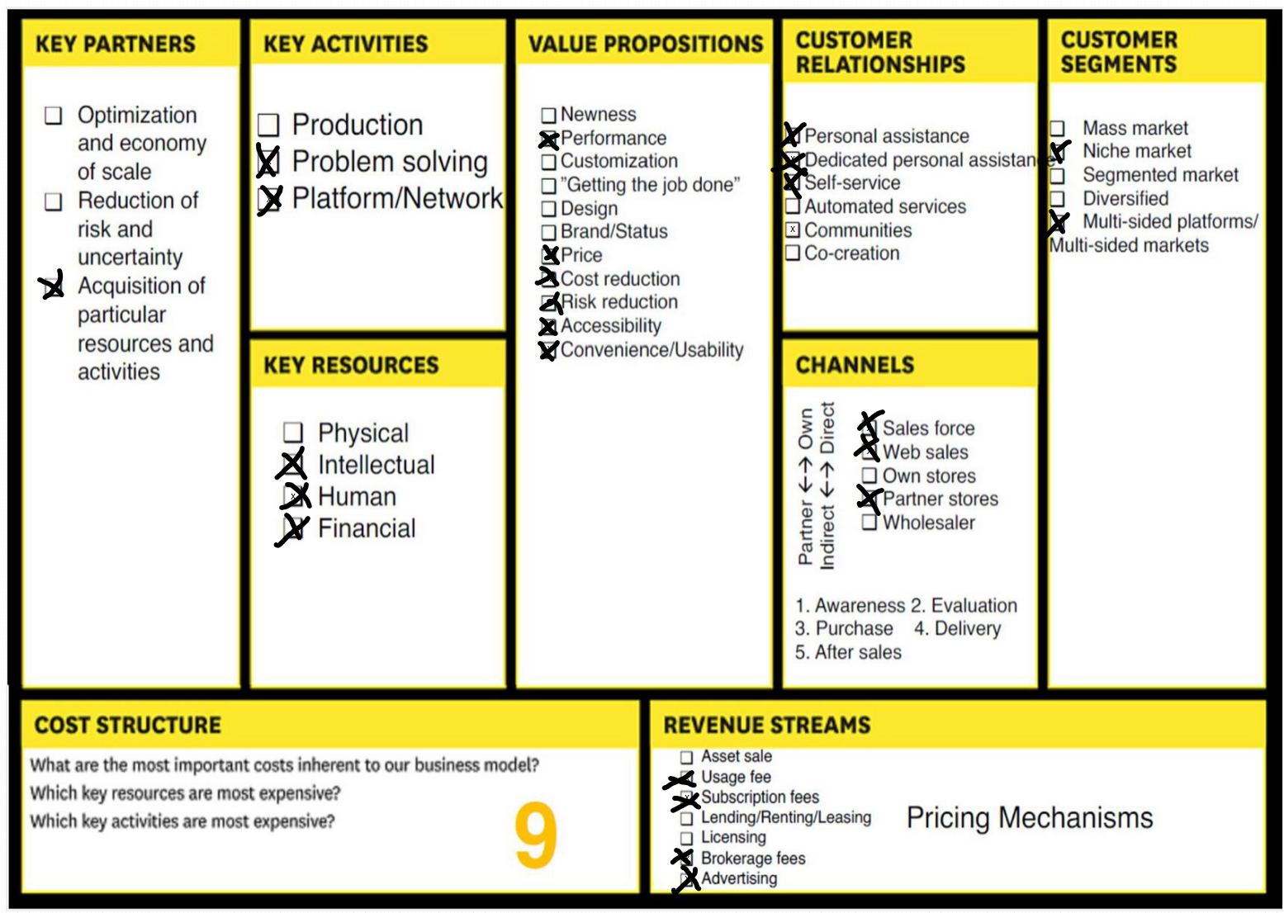



The Business Model Canvas for BidWise explains how the platform will work and generate value for its users.

Our **key partners** will include AI and technology providers to power analytics, legal and financial advisors to ensure compliance, and business networks to help us reach more customers. We also plan to collaborate with debt collection agencies to offer receivable collection services and work with accounting software companies to make the platform easier to use. These partnerships will help reduce risks, optimize operations, and provide the resources needed to build trust in the market.

**Key activities** for BidWise include building and maintaining the platform, improving AI models for accurate valuations, and marketing to attract small business sellers and investors. We’ll also focus on educating the market about the benefits of using BidWise for trading overdue receivables.

BidWise **brings value to sellers** by offering a fast and affordable way to sell their overdue invoices without the high costs and delays of traditional debt collection**. Buyers benefit** from a simple, user-friendly process with access to detailed AI insights to help them make better decisions.

We’ll build **customer relationships** through easy self-service and automated tools, but also provide support to onboard new users and answer questions. Our main customers are small and mid-sized businesses that need cash flow and investors looking for new opportunities.

To achieve this, **we’ll rely on resources** like secure data storage, AI tools, and a skilled team of developers, data scientists, and customer support staff. Financial resources will be essential for building the platform and acquiring our first users.

The platform will **primarily operate online** through a website. Partnerships with business groups and advisors will help spread the word, while online marketing will drive traffic to the platform.

**Our** **main costs** will include platform development, AI improvements, marketing, and legal compliance. Revenue will come from transaction fees, set at 1–5% of each sale, and optional subscription fees for advanced features. In the future, we may also earn from brokerage fees or advertising.

In short, BidWise aims to make selling and buying overdue receivables easy, fast, and smart while creating value for both sellers and buyers.

## Jarmo’s notes and ideas from the 11.11.2024 lecture

* Idea: It would be beneficial to have a direct interface with companies’ systems so that we could suggest selling overdue receivables when we detect a suitable volume of them. With the press of a button, the company could sell the receivables and receive the offered amount of money in return.
* BidWise partially makes debt collection unnecessary. Is this a good or bad thing?
  + Good receivables should remain in collection, while poor-quality receivables can be sold.
* Future Expansion: Potential to expand later to cover B2B and international receivables.
* Collaboration with Major Collection Agencies: A functional solution initially requires effective cooperation with the largest collection agencies. At some point, collection agencies may no longer be needed, and BidWise could even offer reminder and customer service solutions to companies.
* Questions:
  + How quickly could we generate revenue within the first six months?
  + Who would pay?
  + Where would funding come from?
  + What would the development costs be?
  + What would an MVP product look like?

## Identifying potential customers

BidWise’s potential customers fall into two main groups: debt sellers (small and mid-sized businesses with non-performing receivables) and debt purchasers (investors looking for profitable NPL portfolios).

#### Potential customers:

* **Debt Sellers**: These are companies seeking to convert their overdue receivables into immediate cash flow without relying solely on traditional debt collection. By using BidWise, they can streamline the selling process, reduce costs, and enhance liquidity.
* **Debt Purchasers** (Investors): This includes both small-scale investors and larger financial institutions looking for curated NPL portfolios. They benefit from BidWise’s data-driven valuation and risk assessment, enabling them to find and evaluate portfolios more efficiently

#### Potential Partners:

* **Collection Agencies**: These agencies can provide leads on companies that may be potential sellers, as they work with businesses struggling with overdue receivables. Collection agencies could also promote BidWise as an alternative option for companies looking to sell their receivables.
* **Sales Ledger Platform Providers**: Companies offering accounting etc. software could integrate BidWise into their platforms, allowing their clients to access our service seamlessly and sell receivables directly through their existing tools. Initially it could just advertise BidWise.

## Questions for Customers (Debt Sellers and Purchasers):

This is what we can say in the beginning of an interview (in Finnish):

”Tämä haastattelu on osa kouluprojektia, jossa harjoittelemme yrityksen perustamista kuvitteellisella liikeidealla. Työskentelemme kehittääksemme teoreettista alustaa nimeltä BidWise, joka toimisi digitaalisena markkinapaikkana velkasaatavaportfolioiden ostajille ja myyjille. Projektin tavoitteena on ymmärtää paremmin alan tarpeita ja haasteita, jotta voimme simuloida aidon yrityksen perustamista ja luoda toimivan liiketoimintamallin koulutyötä varten. Haastattelunne auttaa meitä saamaan arvokasta palautetta ja näkökulmia, joita voimme käyttää projektin kehittämisessä”

For Debt Sellers:

* 1. What challenges do you face in selling non-performing loans (NPLs) or in managing overdue receivables?
  2. Would a streamlined platform to sell NPLs quickly be valuable to your business? What features would you find most useful?
  3. How do you currently handle unpaid receivables? Have you considered selling them? If so, why or why not?
  4. How much would you be willing to pay for a service that helps you sell NPLs faster and more easily?
  5. Would you prefer a standalone platform, or would you find it easier to use if it was integrated into your existing credit management software?
  6. What would make you feel confident in using BidWise? Are there any concerns that might prevent you from adopting such a platform?

For Debt Purchasers (Investors):

* 1. How do you currently find and evaluate NPL portfolios? What challenges do you face in this process?
  2. Would data-driven insights and risk assessment tools add value when evaluating portfolios? What specific insights would you prioritize?
  3. How frequently do you purchase NPL portfolios? What criteria do you use to decide on a purchase?
  4. Would you be open to a subscription or transaction fee model for access to a curated marketplace of NPLs?
  5. What would make an NPL platform convenient and trustworthy for you? Would you prefer personalized recommendations?

## Customer validation

### KTI-Perintä

Interview conducted on 19.11.2024.

KTI-Perintä is a smaller debt collection company based in Finland. During the interview, they clarified that they do not purchase receivables and have no interest in doing so. Initially, they misunderstood the platform's concept, assuming it was focused on trading B2B receivables in a manner similar to factoring without recourse, where a seller sells a performing invoice for immediate cash and transfers the risk to the buyer. KTI highlighted that platforms dealing with such receivables do not appeal to them, as they often feature unfamiliar or unconventional invoices.

However, KTI shared valuable insights into their current operations. While they do not purchase receivables themselves, they assist their clients in managing and selling their overdue receivable portfolios. These portfolios are regularly auctioned between two other debt collection companies, and the highest bidder acquires them. The process, while functional, is labor-intensive, particularly for new clients, and has led KTI to establish a minimum portfolio size of €200,000 to make the process worthwhile. They noted that if the process were simplified or automated, smaller portfolios could also become viable, unlocking new market opportunities.

One critical point raised was that debt collection companies that do not purchase receivables might perceive this platform as a competitor. They expressed concerns that such a service could redirect receivables they currently manage to other buyers, potentially resulting in a loss of their clients. This dynamic could limit their willingness to support or promote the platform’s growth.

Another major challenge they highlighted was reaching potential users of such a platform and increasing its visibility. KTI suggested that accounting firms and debt collection companies could be key channels for promoting the platform to the right audience. They also emphasized the importance of making the login process as simple and intuitive as possible for users. Integration with financial management systems like Fennoa or Priox could streamline operations and reduce manual workload. They proposed features like a free API and a dedicated button within financial software to facilitate receivables trading.

KTI further emphasized that the platform must host a large number of sellers to attract buyers and ensure sufficient options. Buyers require transparency and comprehensive data on portfolios to make informed decisions. They mentioned that spreading awareness through accounting firms could be crucial for the platform’s growth.

Potential partners mentioned during the interview included OK Perintä and Priox-related services. Credita was identified as a technically competent company, though its current offerings may not align with all financing needs. Finally, KTI highlighted that automation and simplification of processes could make smaller portfolio sales viable, broadening the market and providing value to both debt collection companies and smaller receivables sellers.

#### Recommendations to Improve the Idea

* Position the platform as a partner to debt collection companies, enabling them to offer receivable sales services.
* Simplify and automate the process to attract smaller portfolios.
* Integrate with financial systems like Fennoa to reduce manual work.
* Use accounting firms and financial advisors to promote the platform to potential users.
* Enhance transparency with detailed portfolio data to build buyer confidence.

### S Finance

Interview conducted on 21.11.2024.

S Finance, a financial services company in Finland, explained that they don’t currently need BidWise because they have agreements with three debt collection companies that regularly buy their overdue receivables. This system provides them with consistent cash flow, so they don’t require a platform like BidWise right now.

They believe BidWise could attract many users, especially smaller or relatively new companies that don’t have similar agreements as they have. They also said they would have used BidWise in their early days if such a platform had been available.

S Finance emphasized that trust is key for a new platform like BidWise. They suggested focusing on building credibility and showing users that BidWise is reliable and safe to use. Additionally, they mentioned that the platform should be free for sellers, as the buyers of the receivables benefit the most from this service. They recommended charging the buyers a fee, as the platform greatly simplifies their process of finding and purchasing receivables.

#### Recommendations to Improve the Idea

* Focus on building trust to attract early users.
* Make the platform free for sellers and charge buyers, as they gain the most value from the service.
* Highlight the benefits for smaller and newer companies.
* Develop features that simplify the process for buyers.
* Showcase transparency and reliability to build trust among users.

## Research on the NPL market and trends

In Finland the NPL market is booming since the amount of personal debs in enforcement is higher than ever and still rising. The more there is b2c invoices left unpaid the better the situation is for the NPL market. This means that there is more to trade. This similar situation is happening in all European countries and is mainly due to the higher interest rates globally.

Figure 3. Personal debt in Enforcement in Finland

Figure 4. Debt collection cases (personal debt related) in Enforcement in Finland

## Benchmarking similar business models

Since the planned business model is quite unique, there are not directly any similar business models that trade NPLs in an online platform. However, there is an organization called NPL Markets, which is, according to the company itself, *“A single integrated platform to manage credit portfolios and transactions”*. NPL Markets has a platform, where organizations can store their portfolio and transaction data and easily share these to investors when selling portfolios. However, NPL Markets does not function as a marketplace for the transactions but as a system which leads the buyer and seller from sales to a complete transaction.

Traditional actors such as Intrum, Ropo Capital and OK Perintä are examples of organizations that buy NPLs from organizations in the “traditional way”.

## Reflections about learning

This week we focused on tweaking our business idea through tools like the Business Model Canvas and Value Proposition Canvas. We gained valuable insights into our market and customer needs. Through mentoring and research, we better understood the challenges and opportunities for BidWise.

### Jarmo’s reflection

During this week I focused on refining our Business Model Canvas and contributed to the Value Proposition Canvas. I can now better see the value of the Value Proposition Canvas in shaping and tweaking a startup idea. It's a great tool to highlight the important elements needed to address customer needs.

I also spent time researching potential customers, which turned out to be more challenging than anticipated. I created a list of companies we could approach to validate our idea and understand their situations better. I expect that after these discussions, our canvases will evolve, as we likely haven’t considered all perspectives yet.

On the buyer side, I found that the majority are large debt collection agencies that purchase NPLs, which makes it harder to locate smaller investors as they don’t openly market themselves as buyers. A possible next step might be to directly reach out to smaller debt collection agencies and explore if they are currently purchasing or would be interested in purchasing NPLs.

Another challenge is with companies that have forward flow agreements, where they commit to selling NPLs monthly to a specific agency over a long-term contract. These companies might question the need for BidWise. One potential benefit for them could be splitting portfolios to sell to multiple buyers, potentially increasing their total returns. However, this approach adds complexity and would require BidWise to offer a transparent platform to manage such multi-buyer arrangements. This could be a feature better suited for later development.

In terms of teamwork and time management, I’ve noticed it’s been surprisingly tough to stay on top of everything. We would benefit from a better collaboration tool to streamline productivity and communication. Currently, we use Teams for messages and calls, but responses are sometimes delayed, which affects our productivity. Despite this, everyone on the team is fully committed and genuinely interested in the project.

Finally, pitching has proven to be a challenge. It’s tough to pitch effectively when we’re still defining the core aspects of our idea. But as we gain clarity each week, our pitches are likely to improve. We should probably dedicate more time to pitch practice to build confidence and clarity in presenting our vision.

### Risto’s reflection

I had the honour to pitch my idea to Pekka Abrahamsson at the beginning of the breakout session. This was perhaps the best moment (at least so far) in the course, because I thought I was doing great, but he disliked my way of pitching – which he also mentioned that was nothing like a pitch at all. This made me rethink my view on pitching from being a way of marketing the product’s functionalities to, instead, explaining the whole problem that the solution is solving.

This week’s tasks were to analyse the value of the business idea and to sketch out the first version of our project in a Business Model Canvas. We already started creating the business model canvas last week.

A new insight from this week was to dig deeper into the role of the NPL investor. The European Union strict directive (EU directive 2021/2167) on credit servicers and credit purchasers) that states who is allowed to perform as a credit servicer. As a credit servicer in an EU country, an organization must have its headquarters in that country. In other words, for an organization to be a credit servicer in the whole EU, it must have at least 27 different companies in total.

One thing that changed my approach, or more likely but dug me deeper into the business idea, was identifying the roles of the investors. Any investor can invest in different objects, but not all investors are credit servicers that are entitled to handle NPLs by law. Therefore, investors that are not credit servicers but are looking for investments in NPL need to find partners that are credit servicers or become one themselves. This means, that they somehow have to partner up with a credit servicer to be able to collect the debts from the NPLs. In addition to the transaction fee debited by BidWise, they would also need to give a steak of the incomes to a credit servicer. Would it be better if BidWise would be a licensed crediter, too, or sould BidWise team up with some other major players within the field to enable more investors to the market? Or would it be better for that market if the Key Account Managers at the credit servicers would focus on getting external financing and let BidWise find the debts? The BidWise model would also enable newcomers in the market, since it would mean that new credit servicers would gain access to smaller NPL batches that are available on the market thanks to the easiness of selling smaller batches.

### Eppu’s reflection

This week we had our first mentoring meeting. Pekka Abrahamsson liked our idea, but pitching is still a long way from perfect or even from good. Reflection is the most important part of this scratch book, and we need to write it more. Now after the hackathon, this week feels like the first real working week of this course. The first week guidance felt unclear and incomplete. Also, the Jyväskylä moodle is hard to use when one is used to their home university moodle page.

Filling out the value proposition canvas, we came to conclusion that BidWise should have a place in the NPL market. Although the idea can be amazing, but with no real customer need it will not fly. The next step should be validation of the idea with real customers. This cannot be simulated.

I was meeting with different deep tech startups in Tampere University this week. They were struggling with the same problems as us. One team had an idea to get rid of the batteries in animal monitoring devices used by farmers by capturing energy from the animal movement to power the transmitter of the monitoring device.

They had a working prototype, and I was thinking that this is a concept worth money. The team had thought that too, and they got 750 000 € from Business Finland to make the idea into a company. A study was conducted to get to know what features farmers would like to have in the device. The result of the study was shocking. Farmers do not need the technology at all. They are perfectly happy with their battery powered devices. Batteries last five years and they buy new devices when batteries run out.

This was a good example that the team having an idea need to validate the need with the customers as quickly as possible to minimize unnecessary work. Pivoting should always be an option, and the team should not fall in love with their idea to be open minded to pivot their idea towards the customer needs.

## Market validation and location-specific research

### Scoping out potential market segments

Potential market segments are practically all around the world. However, debt collection is made differently in each country, with national legislation, which makes each country a specific area with separate requirements. As already mentioned before, in the EU the debt-collection industry is regulated by an EU-directive, which means that the procedure is somewhat similar in all EU countries. Since our team only has experience of how NPL trading works in Europe, that is a good market segment to aim at. Initially, because the specific knowledge concerns Finland, this is the market from which it is most optimal to start the NPL platform’s journey. By understanding how the market works, what the local rules and regulations require and by knowing people in the industry, it is a better starting ground.

### Starting market and expansion markets

BidWise’s initial focus will be on the Finland / Nordic region, targeting small to mid-sized companies with B2C receivables and investors interested in local NPL portfolios. Once established, BidWise plan to expand into European markets, leveraging cross-border opportunities and addressing international NPL trading needs. Future growth could also include B2B receivables and partnerships with global investors.

### Analysis of existing NPL platforms

The current NPL platforms largely focus on institutional clients and large portfolios, leaving smaller sellers and B2C receivables underserved. Here's an overview:

1. NPL Markets

* Market: Europe (e.g., Germany, Italy, Spain).
* Focus: Large institutional clients, complex tools for high-value deals.
* Gap: Not accessible for small sellers.

1. Debitos

* Market: Europe (Germany, Austria, Switzerland, broader EU).
* Focus: Auction-based platform for mid-to-large portfolios.
* Gap: Unsuitable for small sellers needing quick, predictable transactions.

1. DebtX

* Market: Primarily U.S., some presence in Europe and Asia.
* Focus: Large portfolios with advanced valuation tools.
* Gap: Lacks customization for small businesses.

Key Takeaway:

BidWise can fill the gap by focusing on smaller sellers, offering a user-friendly, AI-driven platform for faster, transparent, and cost-effective transactions. The Nordic region and underserved European markets present key opportunities.

## Pitch version 3

Hi, I’m [Your Name], and I’m here to introduce BidWise, a smarter way to trade unpaid consumer related invoices, or with business jargon non-performing loans, or in short NPLs.

Every year, businesses struggle with unpaid receivables. Small and mid-sized companies, in particular, face challenges in turning these into cash quickly without relying mainly on expensive and slow debt collection methods. On the other hand, investors often spend too much time searching for quality portfolios, with little transparency or data-driven insights to help them decide.

That’s where BidWise comes in. Our platform connects businesses looking to sell their overdue receivables with investors seeking new opportunities. Powered by AI-driven analytics, BidWise ensures sellers get fair valuations and buyers gain clear risk assessments—instantly.

Imagine this: A small business can upload their receivables, and with the click of a button, receive offers from multiple investors. No waiting, no uncertainty—just streamlined transactions. For investors, our tailored portfolio recommendations and transparent data make finding and evaluating NPLs effortless.

We’re starting with the Nordic market, where small businesses often lack solutions for selling B2C receivables. As we grow, we plan to expand across Europe, addressing an even bigger gap in the NPL market.

To build and launch BidWise, we’re seeking €300,000 in funding for the first year to develop the platform, onboard partners, and execute our go-to-market strategy. We anticipate modest revenue of €50,000 in year one as we establish our presence, followed by €200,000 in year two, with rapid growth expected thereafter as we scale operations and expand to larger markets. By year five, we project multi-million euro revenues, driven by increased transaction volumes and customer acquisition.

At BidWise, we’re not just creating a marketplace; we’re building a more accessible, transparent, and efficient future for NPL trading. Whether you’re a seller or an investor, BidWise is your smarter choice for trading debt.

Let’s make the future of NPL trading faster, simpler, and smarter - together.

# WEEK 4: MVP

## Insights from the 18.11.2024 lecture

The lecture provided the team with new tools for further processing the business idea and the product. the Minimum Viable Product (MVP) process helps us map how we should proceed with shaping our idea to a concrete product that fulfils the minimum requirements set by the market, i.e., the users.

The guest lecture by Jarno Mikkonen gave valuable insight in the importance of registering patents and gaining copyrights to the products. At least a patent pending should be put into processing before revealing an idea, in which a patent can be considered being an efficient way of protecting the intellectual property of the product. However, our product is a product consisting of a platform for NPL trading, which means that the intellectual property is not very unique; there are tremendous amounts of online platforms already. However, the name BidWise could, of course, be registered as a trademark.

## MVP development

The team decided to prepare a prototype that would demonstrate how the MVP would look like. This would be done by creating a mock-up MVP, with the aim to make the plans visual and to have a first product to work with further. To be more efficient, the mock-up should have been just pictures, but Eppu wanted to improve his skills to make a real web page with yet no real functionality.

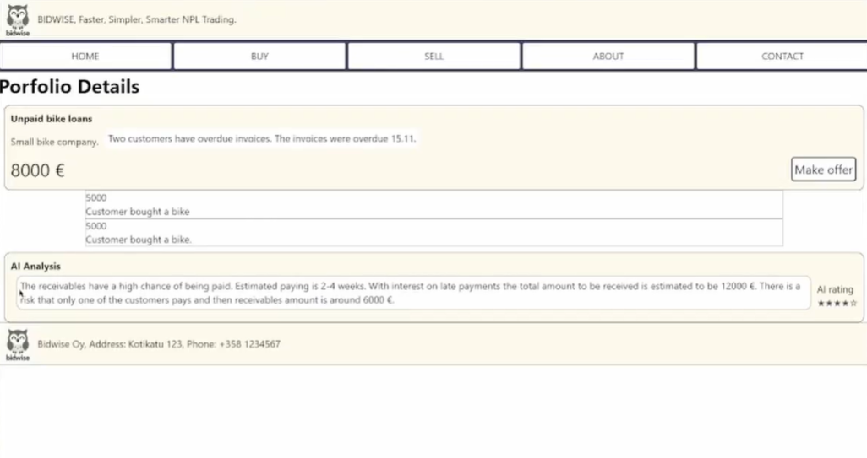

## Reflections about learning

### Jarmo’s reflection

Working on the MVP was a really eye-opening experience. It’s amazing how just having something simple to show can make an idea feel so much more real. For BidWise, putting together a mock-up helped us get a better idea of what we’re actually trying to build and how it could work in practice.

I realized that an MVP doesn’t need to be fancy—it just needs to get the main idea across. It’s easy to overthink and try to include too much, but the whole point is to keep it simple and focus on what really matters.

Eppu’s decision to make an actual webpage instead of just pictures was really cool. It gave us something more concrete to work with. Even though it wasn’t fully functional, it added a lot of value to the project already. It also showed the importance of a teamwork, everyone should play with their strengths and bring their own skills to the table.

One exciting thing that came out of this process was the idea to allow anyone to become an investor, not just debt collection companies. Opening up the platform to a broader audience could really change the game and make it more accessible for people who’ve never been part of this market before.

This whole process has been a great reminder of how important it is to test and validate ideas early on. It’s not about making something perfect right away, it’s about making something that works well enough to get feedback and wiork from there.

### Risto’s reflection

Defining an MVP is simultaneously an easy and a difficult task to do. As the term describes, it should be a minimum viable product, showing the lowest acceptable functions and standards. However, it should also show the usability of the product and describe the supply chain. For BidWise, the minimum viable functionalities are covered by a simple website. Eppu made a huge job by not only drawing up a mock-up but creating a first web page for BidWise.

BidWise is an online platform. There are multiple platforms online and Bid Wise does not bring any new innovative technological solution. The idea per se is new, being a new kind of platform to new audience (investors who are not debt-collectors but rather newcomers to the investment market). It is not inventive, and don’t serve a special technical purpose. If we manage to fulfil the needs of the non-traditional investors in a traditional market, we are going to make far with this idea.

### Eppu’s reflection

We decided to do a mock-up page of the Bidwise platform. I know the efficiency is the key in problem validation. Most efficient way of making the mock-up would have been just to make pictures to show the interface of the platform. However, I wanted to validate my own skills as well. I wanted to practice my web-dev skills, and I used couple of hours to make the raw version of the mock-up page.

The development process of any startup idea should always focus on the needs of the potential customers. Validation of the problem. Validation of the customer. Validation of the solution. Validation of the market. These all needs to be done to prevent unnecessary work in the early stages of the startup journey.

## Pitch version 4

Hi, I’m [Your Name], and I’m here to introduce BidWise, a smarter way to trade unpaid consumer related invoices, or with business jargon non-performing loans, or in short NPLs.

Every year, businesses struggle with unpaid receivables. Small and mid-sized companies, in particular, face challenges in turning these into cash quickly without relying mainly on expensive and slow debt collection methods. On the other hand, investors often spend too much time searching for quality portfolios, with little transparency or data-driven insights to help them decide.

That’s where BidWise comes in. Our platform connects businesses looking to sell their overdue receivables with investors seeking new opportunities. Powered by AI-driven analytics, BidWise ensures sellers get fair valuations and buyers gain clear risk assessments—instantly.

Imagine this: A small business can upload their receivables, and with the click of a button, receive offers from multiple investors. No waiting, no uncertainty—just streamlined transactions. For investors, our tailored portfolio recommendations and transparent data make finding and evaluating NPLs effortless.

We’re starting with the Nordic market, where small businesses often lack solutions for selling B2C receivables. As we grow, we plan to expand across Europe, addressing an even bigger gap in the NPL market.

To build and launch BidWise, we’re seeking €300,000 in funding for the first year to develop the platform, onboard partners, and execute our go-to-market strategy. We anticipate modest revenue of €50,000 in year one as we establish our presence, followed by €200,000 in year two, with rapid growth expected thereafter as we scale operations and expand to larger markets. By year five, we project multi-million euro revenues, driven by increased transaction volumes and customer acquisition.

At BidWise, we’re not just creating a marketplace; we’re building a more accessible, transparent, and efficient future for NPL trading. Whether you’re a seller or an investor, BidWise is your smarter choice for trading debt.

Let’s make the future of NPL trading faster, simpler, and smarter - together.

## Customer validation

#### Demographics, trends, patterns of change, and life-cycle stage of the industry

The demographic trend of NPL trading is, at least within the European Union, restricted to national markets. This is because of the customers’ strong position in the EU member states’ customer protection regulations. Due to EU regulations, only the nation in which the original trade has been done, can be the home nation for the debt-collecting agency. In other words, to be able to collect debt in an EU country, an organization must establish a subsidiary company in that member state. Each member state has its own legislation and procedures, which affects the attractiveness level of this kind of business in countries.

#### Barriers of entry and are there any barriers you can set up

The major entry barrier consists of the current market, which has been established in a specific way, which in turn has become the traditional way for trading debt. Normally, the debt collectors have agreements with customers, who more or less are bound to the debt-collecting agencies with their NPLs. Trading NPLs in a platform-based environment, with a firm with which the organization has no specific agreement upon that trade, is almost unique and currently only occurs for very big transaction amounts. Tackling how organizations could sell their NPLs to the open market instead of to their cooperative partners is the biggest barrier towards organization with existing debt-collecting partner agencies. However, the coin can be twisted as a benefit for BidWise, too. By offering an easy and more transparent way of trading NPLs, any potential binding cooperation agreements with specific agencies become more irrelevant.

#### The status of technology and R&D expenditures, and what is the level of innovation

Initially, the R&D expenditures can be kept low, because the platform is non-complex to its structure and basically quite easy to build. After all, it is a platform with a database, customer (investor or seller) profiles, transaction details and trade documentation. In further development steps and when there is further trade data available, artificial intelligence will be implemented to determine the target prices for the debts.

#### Typical profit margins in the industry

The cost of debt collecting can be both in percentage of the sum that is to be collected or a listed price for the service. Typically, the profit margins are high, ranging from 15-60 per cent, due to the risk in investing in debt. Depending on the probability of getting the money back or not, also the profit margin fluctuates.

#### Opinion leaders in the industry and how do they affect the industry

Intrum, Lowell and OK Perintä are the biggest degt-collecting organizations in Finland. These organizations are not only represented by themselves but also by the Collection Agencies’ Association, which is the roof organization for debt-collecting agencies in Finland. From the State of Finland’s side, it is the Regional State Administrative Agency (AVI) who has the controlling role. An organization must be in AVIs register to gain their license and AVI is also the controlling agency in the industry.

#### Distributors, competitors, retailers, and others saying about the industry

The industry is perhaps not the most respected from the customer perspective, since the business idea is to collect consumer debts. However, the platform and its functionality would not be considered by the customers, because it is only a platform through which the NPLs switch owners.

#### The demographics of the target market?

The three biggest debt-collection agencies in total have a revenue of about 250 m€ <https://www.hs.fi/talous/art-2000008004598.html>). In October 2024, there were 365 000 persons in Finland with a payment default indication. On average, each of these persons has 14 payment default indications, which means that the total amount of indications is 5,11 million to the amount. There are currently 84 organizations in AVI’s register of registered debt-collecting agencies in Finland. The Collection Agencies’ Association only has 15 members, so the market cannot be considered equivalent to the number of agencies they are representing.

#### What is the profile of the first customer?

For the first transaction to succeed, both an investor and a seller are needed. Therefore, there should be two first customers. Most likely, the first customers are a small or mid-sized company, desiring faster cash flows from accounts receivable.

#### How to approach customers to learn about their needs

In an initial phase, potential customers to the platform are contacted through phone calls and e-mails, where they are requested to give input on whether this kind of platform is of interest to the organization. The input given by the potential customers will affect how the platform is developed further. Also, the customers will confirm that there is a need for this kind of a solution for trading debt.

#### Competitors and how are you differentiated from them

The competitors can be divided into two segments: competing platforms and potential investing customers, i.e., debt-collecting agencies. Since the platform market is quite new, there is only one other platform, NPLMarkets, that shares the same kind of business model as BidWise. However, NPLMarkets focuses on big transaction portfolios rather than small and mid-sized companies’ portfolios.

The other competitors are the debt-collection agencies that strive to find cooperative agreements directly with companies who are eager to have a one-partner method and sell the NPLs according to the agreement.

# WEEK 5: METRICS

## Thoughts on lecture 25.11.2024

At the beginning of the lecture, the top reasons for why startups fail were presented. No market need, lack of financing and poor product-market fit were the main reasons for startup failure. I would have guessed that the lack of financing is one of the main reasons, but no market need and poor product-market fit were surprises. Most startup products aren’t going to burst out like Spotify, that’s obvious, but that they wouldn’t get it running was quite surprising. Poor timing and not the right team were also quite high on the lists. Timing is crucial for s startup, so is working with a team that is motivated towards the target and a “fit” for working together.

For BidWise, there are most likely two major barriers that must be broken to break through: the sales approach and the financing. Selling the platform with the right approach will be crucial for the platform’s business idea to work properly. This is because buying non-performing loans requires that the transaction is done by a debt-collecting agency. Since there currently are only 84 licensed companies or private persons who can do this, the idea must be sold to them as a way of increasing sales through external investors, not as a competitor to the debt-collecting agencies. Also, it is of importance to sell the platform’s investment possibilities to smaller agencies and international organizations who are trying to enter the local market. Likewise, the platform should be sold to investment banks and risk capital funds, who are seeking new investment methods to their investment portfolios.

## Defining key metrics for BidWise

#### Number of trades per month

To know the performance of the platform, the organization needs to know how many transactions that have been made, i.e., the number of trades. Also, we need to know how much capital is traded via BidWise and how it evolves. It is the main source for our revenue stream.

### User engagement metrics

#### Visits per day

To know how big the traffic to the website is, visits per day will give us an indication of how often users will visit the website. If the website traffic is very active, but only a few trades or no trades at all take place, it indicates that either the prize is still too high, or the trades are of the wrong risk rate or quantity. With this data, it is easier to approach customers and better understand why the trades are not taking place. Simultaneously, the customer feedback might provide valuable information of the need of a monitoring tool, for example.

### Financial performance indicators

#### Revenue per month (€)

To follow up the performance of the business, financial performance indicators must be put in place. One of the most important indicators for any business is the cash flowing in, i.e., revenue.

By following revenue per month, we can ensure that there actually is a business behind our product and that there are interested organizations both on the selling and investing sides. The revenue is, especially during the first years, dependent on both how the market perceives the new idea of trading through a platform instead of the conventional way of trading and of how we will manage to sell BidWise to companies.

#### Customer revenue per month (€)

Another revenue metric that is important to follow is customer-specific revenue, showing us how much that is sold through which customer and how much each investor has been investing in the company. By following this quite simple metrics, it is easier for BidWise to contact specific customers for feedback and to target similar customers with the same kind of needs.

#### Average value per trade (€)

When selling trades, the average value per trade indicates on how big trades are on average that come to the platform. By knowing the average trade size, it is easier to forecast the total value of the transactions that will go through the platform. This is important information because the most significant revenue stream for BidWise is transaction-related commission. The metrics could also be what the average trade made on the platform is, but this metrics would rather be used for targeting new customers to the platform from the right customer profile.

## Reflections about learning

### Jarmo’s reflection

Working on the metrics for BidWise was a new experience for me. I’ve seen KPIs before, but creating our own for a platform like this was different. I learned how important it is to keep the metrics simple and useful so that we actually know what’s working and what’s not.

I think it’s really important to focus on things like how many users we get and how much money is coming in and flows thought BidWise. But at the same time, we shouldn’t overcomplicate things. If the metrics are too hard to track, they just end up being useless. Also, I think, the KPIs will be changing a lot since the idea is also evolving a lot.

Also, it’s been good to work with Risto and Eppu on this. Risto knows a lot about numbers, and Eppu brings a tech perspective, so together we’re figuring it out. These metrics will help us understand how BidWise will be doing and what would need to be improved.

### Risto’s reflection

Because I have a background as working as both an auditor and a controller, I am quite used to seeing businesses form a number-angle. Metrics have been part of my working-life since day one. However, defining the metrics for a platform-based business is something completely new to me, and thus the customer performance metrics are, too. However, at such an early stage, the metrics shouldn’t be 1) be so complex that they are irrelevant at this first stage, 2) too hard to follow and 3) hindering growth.

When speaking of growth, it should be important to find metrics for financial, user, and operational purposes, without having them colliding with one another. If two metrics are working in opposite directions, they create an obstacle for growth.

### Eppu’s reflection

I have got interested in financial stuff just recently. I have been aware that knowing your numbers is crucial for a startup to be credible. One reason Miki Kuusi got investors to be attracted to Wolt was clear calculations of the financial plan for years to the future.

I am more of a technology type myself than a financial person. I can’t say that I understood fully all the financial calculations and metrics needed, but I know that someone in my startup team needs to be clear of details. I understand the bigger concept of acquiring customers, getting revenue and keeping old customers. Good we have Risto in Bidwise team to be in charge of the euros.

## Pricing model development

For BidWise, getting new sellers on board is crucial. Based on feedback from sellers, we decided that there should be no costs for them to join or trade on the platform. Instead, we plan to generate revenue by charging buyers a commission of 1–5% on the traded capital.

Right now, we’re unsure about what factors should influence the commission rate. It’s clear that as the platform grows, we’ll need to find ways to increase commission rates without losing buyers, but how to do that is still something we need to figure out.

The focus is on keeping things simple and attractive for sellers while ensuring buyers see enough value in the platform to justify the fees. This balance will be key to making BidWise sustainable in the long run.

# WEEK 6

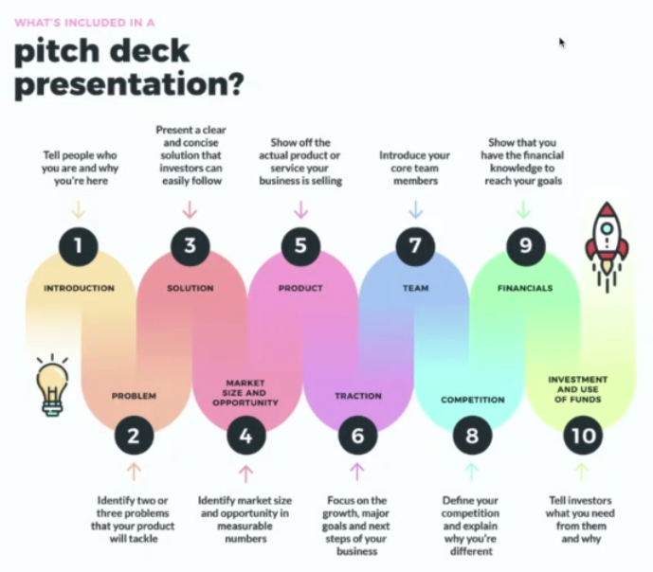

## Thoughts on lecture 02.12.2024

In this week’s lecture, the pitching process was on focus. We already had five earlier versions of the pitch, but now we updated the pitch to better fit the ten-step process including the introduction, problem, solution, market size and opportunity, product, traction, team, competition, financials and investment and use of funds. This has affected both how we have constructed the pitch, and in which order the slides and areas of the pitch are mentioned. The pitch has developed from the first version both visually and with the intended speech line.

The Juicero case was a good example of how far a really good pitch can take you. Doug Evans succeeded in convincing investors of a product that, like said in the lecture, sold itself out from the market with bags that could be squeezed with the bare hands. Also, halving the price of the machine from the initial $799 cannot only shows how little the entire launching and sales process was thought through. However, this lesson shows us the importance of a neat pitch. The difference between our pitch and Evans’ pitch is that

## Financial calculations and projections

Since the whole project is still in its very initial stages, it is hard to estimate how the figures will look like for the coming two years. However, since that is one of the most important things while convincing investors to buy your product, some assumptions need to be made to create a forecast. We have created a cash flow statement, that is partly relying on free labour from the project team and of minimal, or no, technical consultation or work from externals. In our team, we have sufficient knowledge in web programming and the technical development can be made with internal resources for the MVP-stage. Also, the sales have begun to boost with already two debt-collecting agencies being interested in our product. Therefore, the first year’s revenue is planned to consist of the first interested investors, who are planned to be the first users of the platform. Platform subscription revenue is estimated to be 0 Euros per month the first year, because the first customers will be paying by giving the crucial first feedback that is needed for the further development of the platform. Also, it is a lot easier to gain cooperative partners if the testing period is free of overhead costs. The second year, the subscription fee is estimated to increase to 3 500 euros per month, equalling 500 euros per company. The revenue is estimated to grow successfully during the first year with 1 000 euros per month. The second year, the budgeted revenue is planned to continue in the same way, with 1 000 euros per month. The total revenue for the first year is estimated to be 75 000 euros and, already for the second year, 240 000 euros.

The costs for the first year are summed up to 97 800 euros and, for the second year, 213 600 euros. Even if the second year’s costs are over double the higher, the operating costs are in fact double the higher during the first year, because the second year BidWise is planning to pay salaries. The reason why the costs for the first year are double the size of the second-year costs has to do with the costs to configuring the platform and setting up the business. These costs consist of platform development and setting up the AI price and risk estimator, configuring the cloud infrastructure, website development and model maintenance and training. Permanent overhead costs consist of the website’s security costs, legal and compliance costs, office costs and accounting costs.

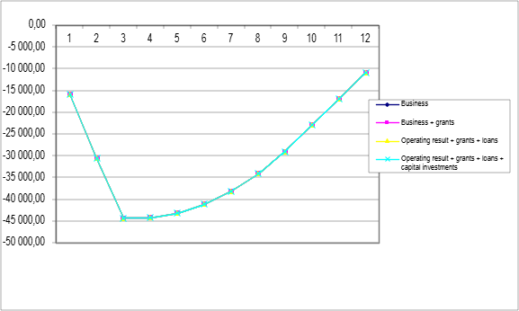

Figure 1: Cash-flow calculation result (cumulative), year 1.

As can be seen from Figure 2 below, sales grow successfully with 1 000 euros per month from being 1 000 euros the first month.

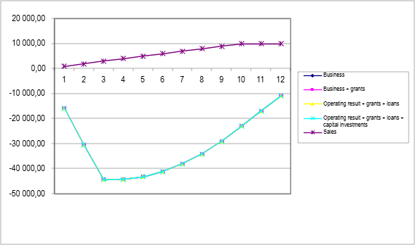

Figure 2: Cash (cumulative), year 1.

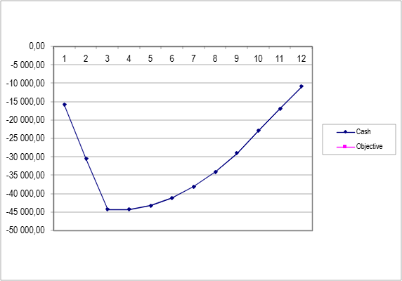

Figure 3: Objective cash

For the first 12 months, the cash sufficiency is negative. The cash sufficiency consists of the cash divided with the sum of the previous three months’ cost. The cash sufficiency being negative is not that odd, because it is this is a crucial startup period for the company and the revenue stream is strongly depending on the developed cooperation.

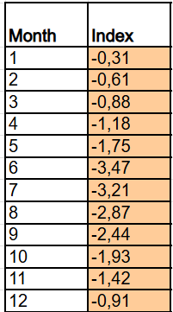

Figure 4: Cash sufficiency for the first year.

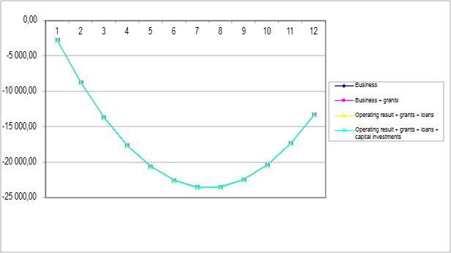

Figure 5: Year 2, cash-flow calculation result

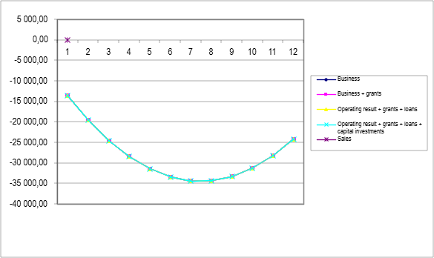

Figure 6: Year 2, cash (cumulative)

For the second year, the cash sufficiency is still slightly negative. This is because of the salary costs the second year.

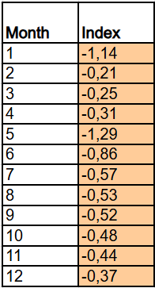

Figure 7: Cash sufficiency for the second year.

## Video planning

The industry of non-performing loans is complicated and probably not familiar to the majority. This is why it’s important to explain it in a simple and clear way. A good video can show how BidWise works and why it’s useful for both sellers and buyers. By making the process easy to understand and showing the benefits, we can help people see the value of using the platform.

### First draft of the video script

The first draft of a video script was made by Eppu, who successfully created a splendid video, that in a funny but very educative way described how the service works for both buyer and seller.

This was an important step in making the concept easier to understand and engaging for the audience. The video managed to simplify the complicated process while keeping it interesting and relatable.

# WEEK 7: THE RIOT

Last week was all about getting the video, slides, and pitch speech ready. Everyone was busy making sure everything looked good and made sense.

Eppu worked on finishing the video, adding the final touches to make it clear and easy to understand. The rest of us focused on the slides, making sure they were simple, nice to look at, and matched the story we wanted to tell.

We also spent a lot of time practicing the pitch, trying to make it short, clear, and interesting. Everyone gave feedback, and we made small changes to improve it. It felt like a lot of work, but it was great to see everything finally coming together.

Despite the complexity of our idea, we feel we succeeded quite well. Presenting such a challenging concept wasn’t easy, but overall, things went smoothly, and we’re proud of the effort we put in.

## Preparing the final video

Eppu took on the challenge of creating the final video, and it followed a simple yet effective narration to explain BidWise’s functionality from both the seller’s and buyer’s perspectives.

The video begins with a small e-bike business owner struggling with two unpaid invoices. Needing quick cash flow, he logs into BidWise, uploads his receivables, and gets an instant AI-generated valuation and description. With just one click, his portfolio is listed on the marketplace, ready for buyers. Now, he only must wait for offers.

Next, the video shifts to the perspective of an investor searching for new opportunities. They browse BidWise listings, guided by AI-driven star ratings that highlight the best deals. The investor spots the e-bike portfolio and, after reviewing the AI analysis, decides to make an offer. For those without debt collection capabilities, BidWise offers integrated solutions with debt collection agencies, making it easy for anyone to invest without hassle—just a single click.

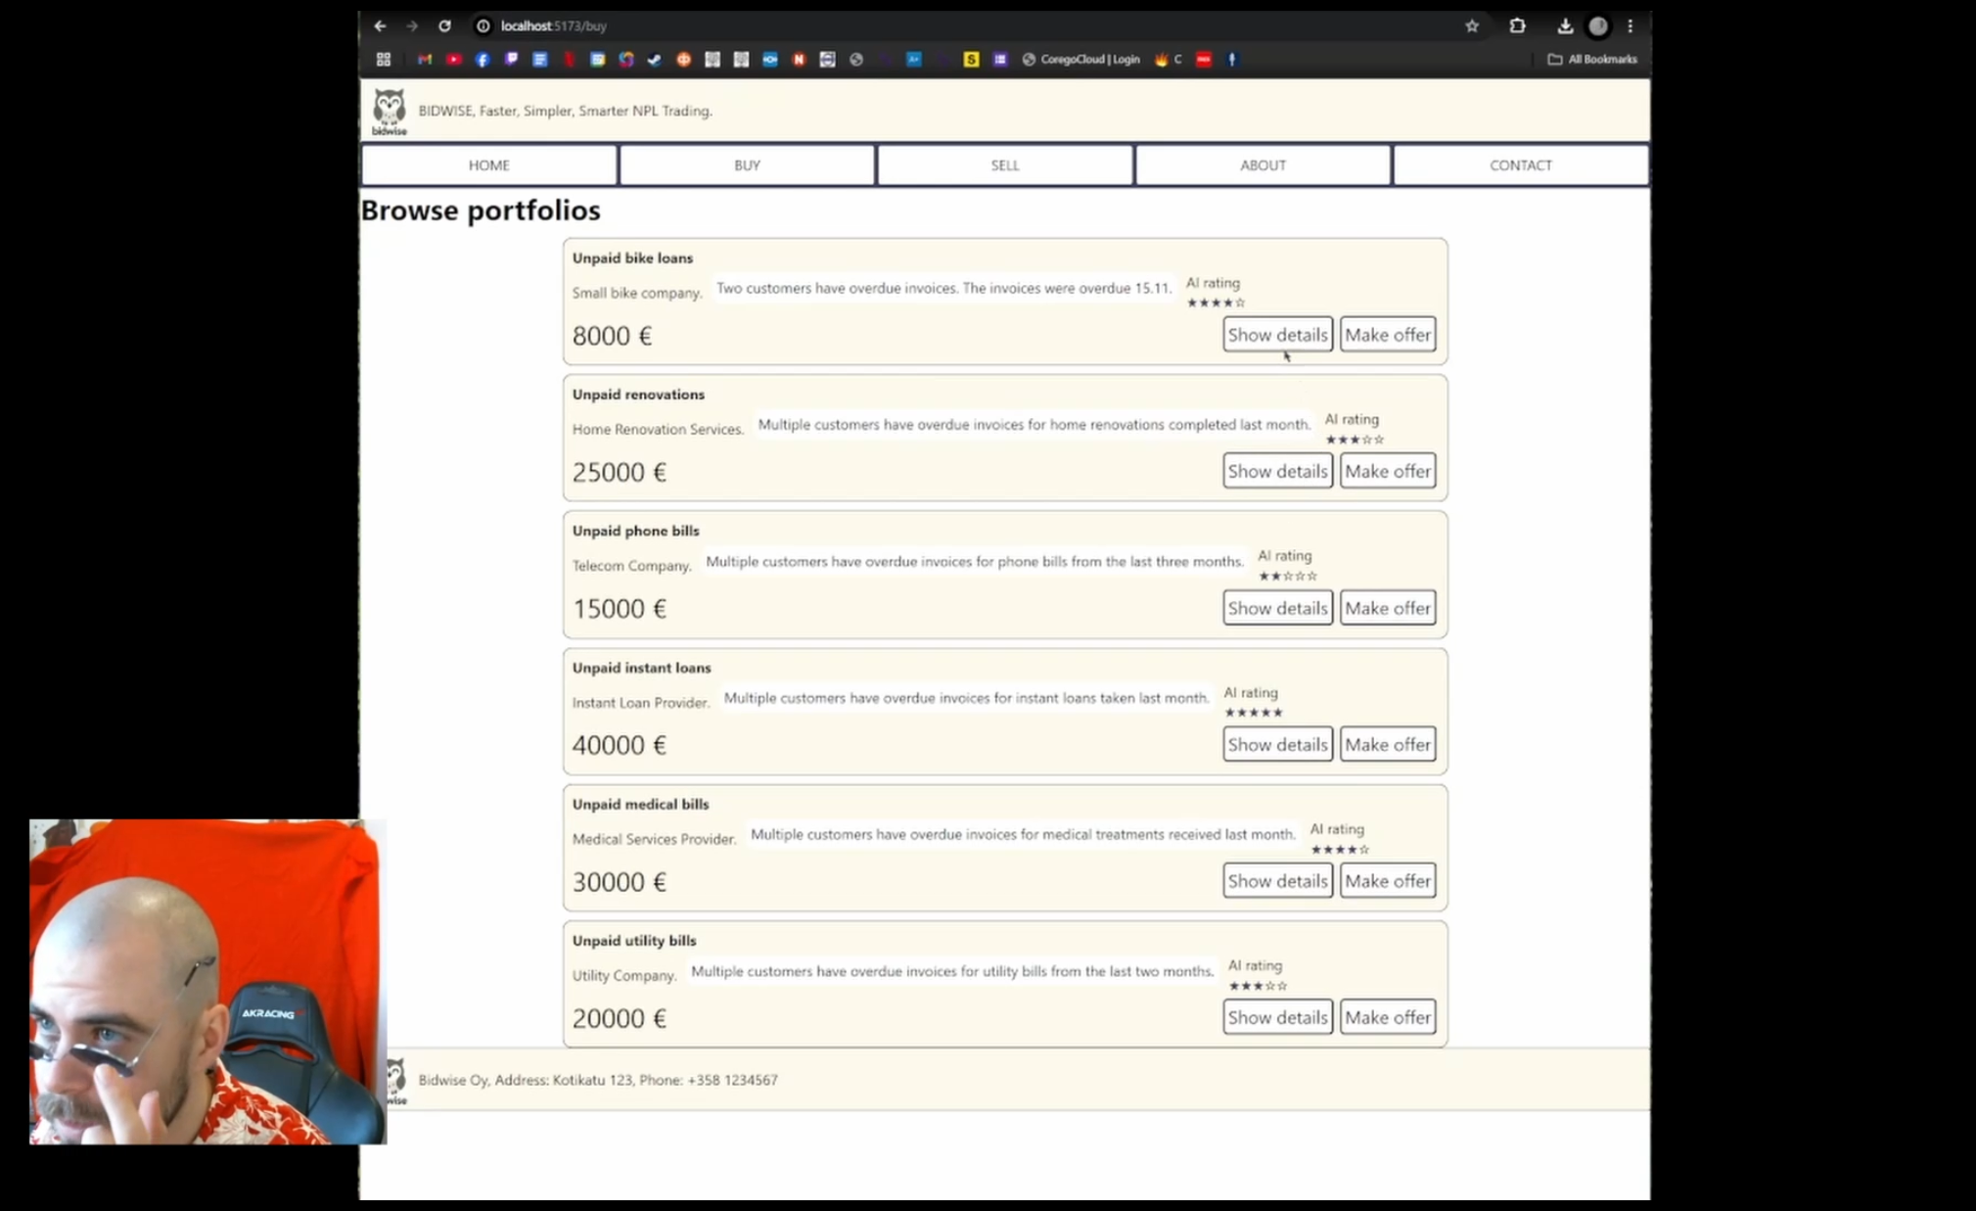

The video closes with a clear message: Smarter. Faster. Simpler. A new way to trade overdue receivables with BidWise.

### Video narration

This is a small e-bike business owner.

He needs money to cover from two customers who have not paid their e-bikes in time.

Apparently, he knows what he is doing and goes to Bidwise. After logging in he can just upload the receivables. AI model analyses the portfolio behind the scenes and gives immediately an estimated price and a short description. Just one click and portfolio is listed for open market.

Now just wait for the magic to happen.

Here is an investor who is looking for new ways to make the best use for his money.

He has found bidwise and checks the listings. AI model has evaluated all listings and shows 1-5 stars to show good deals to customers.

The guy finds the e-bike portfolio just listed and looks at the AI analysis. A little bit of risk, but the customers will probably pay in the next few weeks.

He wants to make an offer.

Debt collecting agencies can buy portfolios directly, but most of us do not have any way of collecting the debt just bought. Luckily bidwise has a solution. Ready made deal of debt collecting agencies to collect the debt for you. Investor does only need to press the button.

Smarter Faster Simpler, NPL trading

## Final pitch presentation

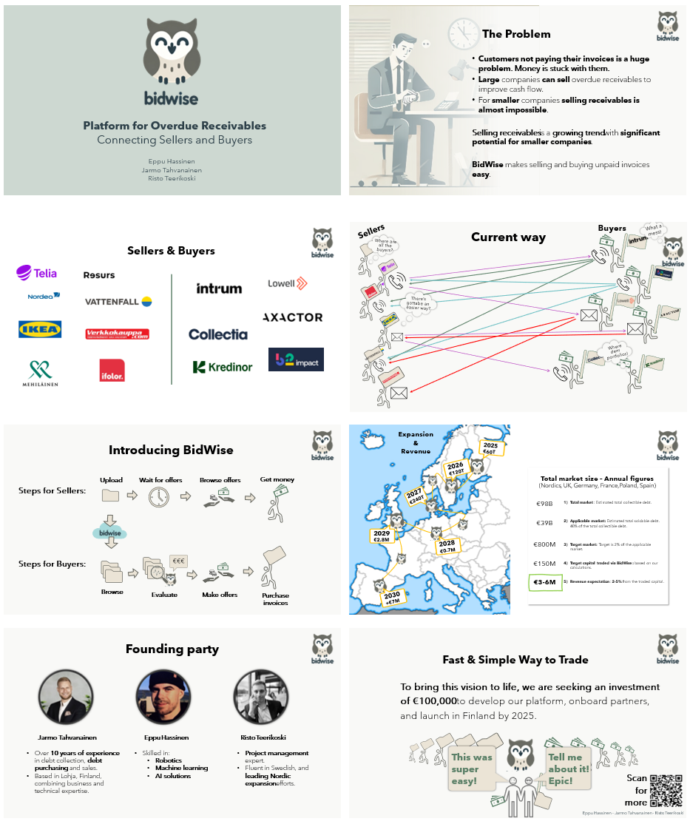

This is our final pitch presentation slide deck. There is still a lot to learn how to pitch better and to highlight the right things during the pitch and presentation. We managed to pull this presentation pitch in 3 minutes that was the target. We had to skip some important parts and this shows how hard it is to explain something complex in a very brief manner.

#### The Final Pitch:

#### Slide 1

Hi, I’m [Your Name], and I’m here to introduce BidWise, a platform to trade overdue receivables.

#### Slide 2

First of all, our team has a great experience in debt collection and debt purchasing.

For companies of all sizes, customers not paying their invoices is a huge problem,

and while larger companies can sell their overdue receivables to improve their cash flow,

smaller companies still need to use traditional debt collection services to collect their receivables.

However, selling receivables is becoming a more frequently used solution. This trend has a great potential especially for smaller companies.

That’s where BidWise comes in — helping companies of all sizes to sell or buy overdue receivables.

#### Slide 3

This slide shows examples from our two key groups:

sellers, on the left, the ones with overdue receivables, and

buyers, on the right, searching for receivable portfolios to buy.

BidWise connects these groups for easier and faster transactions.

#### Slide 4

This is the current way of selling and buying overdue receivables.

For sellers, selling overdue receivables for quick cash flow is complicated. And also buyers struggle to find opportunities.

The current process is slow, unclear, and frustrating for both sides, showing the need for a simple and fast solution.

#### Slide 5

Introducing BidWise

BidWise is a platform that connects sellers and buyers, making the process of managing overdue receivables simple and fast.

For sellers, it offers a fast way to get immediate cash flow instead of waiting years to collect payments. Companies of all sizes can easily sell their receivables and find the best price.

For buyers, BidWise provides easy access to new opportunities across multiple countries with a streamlined process that saves time.

#### Slide 6

The market for selling overdue receivables is growing.

This map outlines our growth plan, starting in Finland in 2025 and expanding across the Nordics and Central Europe by 2030.

By 2030, BidWise aims to handle 150 million euros in traded capital, generating 3 to 6 million euros in annual revenue through transaction fees.

#### Slide 7

We are a team of university students combining expertise in debt collection, tech, AI, sales and management. With our skills we’re ready to transform this market.

#### Slide 8

So, BidWise. A fast and simple way to trade overdue receivables.

To make this vision a reality, we are seeking an investment of 100,000 euros.

This will help us develop our platform and successfully launch in Finland by 2025.

If you are interested in making big money, now is your chance.

## Final reflections about learning

### Jarmo’s reflection

Working on a startup is both challenging and rewarding. It’s exciting to come up with new ideas to solve problems and improve concepts. The learning curve is steep, and I’ve found it to be an incredible way to acquire new skills and stay updated on the latest trends. For me, startup work feels like regular business management, but on steroids—it’s fast-paced, dynamic, and requires constant multitasking. It might even be ideal for someone with ADHD, as it demands rapid iteration, problem-solving, and attention to various aspects at once.

That said, startup work isn’t for the perfectionists. It’s about working with MVPs and optimizing what’s necessary to make things look and feel functional, even if they’re not fully polished. A startup is like a duck: calm and composed on the surface, but paddling furiously underneath to stay afloat and move forward.

During this course and our startup journey, it’s been enriching to connect with new people and hear insights from those deeply embedded in the startup world. Their advice has been invaluable and has expanded my understanding of what it takes to thrive in this space.

I now see why experienced founders often say you need to fail several times before finding the right idea and business model. This process takes time and experience, it’s like a game where you focus on learning what’s essential to succeed while recognizing there’s always more to discover. Success often requires a combination of skills, connections, timing, and even a bit of luck. Interestingly, luck in startups seems to be about creating the right conditions: being active, building networks, and staying open to opportunities.

Overall, this course has been incredibly valuable. I’ve gathered a wealth of material that I’ll keep for future use, and I hope to one day have the right mix of factors to launch something real. Until then, I’ll keep generating ideas, testing them, and learning from both successes and failures. As Thomas Edison famously said, “I have not failed 10 000 times; I’ve just found 10 000 ways that won’t work.” This quote perfectly sums up the startup journey.

### Risto’s reflection

### Eppu’s reflection

I was happy that the team got such an interesting idea from Jarmo. It was truly inspiring to work on the problem. I did not have any prior experience on how to start a startup and how to succeed except one other course I studied at the same time as this course.

Now I have good understanding about the making of a startup using lean methods. The initial idea is not the usual problem. The lack to pivot the solution to right direction is the crucial part of finding a product-market fit.

# SUMMARY

#### Project Overview

BidWise is our idea for an AI-powered marketplace to trade overdue receivables. The goal? Make the whole process faster, smarter, and way easier. Think of it as bringing sellers of all sizes and investors together on a platform that actually makes sense and works for everyone.

#### What we did so far:

We started with a simple concept, did some digging into the market, brainstormed like crazy, and planned how this thing could actually work. We also got feedback from people in the field by interviewing sellers, which helped us tweak and improve our idea.

#### Lessons Learned:

We learned a lot—like how selling overdue receivables is a hassle for small companies, and buyers really need better ways to find portfolios they can trust. Turns out, there’s a huge gap here, and BidWise could fill it.

#### Challenges and Solutions

It wasn’t all smooth sailing. Figuring out only a fraction of regulations and explaining why this platform is worth it wasn’t easy. But we brainstormed, problem-solved, and found ways to make BidWise simple, valuable, and user-friendly. We also got new ideas how we could improve it even further. There is still a lot to tackle and cover to actually get this idea to fly. It also costs a lot as it would need some help from experts to keep the idea trustworthy.

#### Potential Impact and Value

If BidWise becomes a reality, it could make life so much easier for companies of all sizes and also for investors, such as debt collection companies, but also any other investor could chip in if they wish to invest in overdue receivables. Basically, no more confusing processes — just quick, clear, and smart transactions. We could really shake things up in the overdue receivables market.

#### Next Steps

We’re thinking about taking this beyond the classroom. More testing, more fine-tuning, and who knows maybe we’ll actually launch BidWise as a real business. If nothing else, we’ve learned that turning ideas into action is what startups are all about. And who knows? Maybe this is the start of something big. Or at least something worth

# Idea Storage:

Here everyone can add any ideas that pops up in his/her mind!

#### Quote for BidWise:

Quote 0.1 “It’s a faster, simpler, and smarter way to trade debt.”

#### Tutorials for users:

On the website there should be simple video or text tutorials to guide sellers and buyers on how to use the service and also generally manage overdue receivables efficiently, ensuring a smooth onboarding process and reducing any hesitation for first-time users. Also builds trust. This could be joint tutorials, webinars etc. with market leading debt collection companies.

#### Premium Features:

Start free, add paid tools like AI analytics later. For buyers, get the information about new portfolios in advance, get intel, get extra information etc. For seller, gain help in making the portfolio more tempting and get a better price for it.

**Pricing strategy:**

The more seller sells, the better price they get. If they get over some specific tiers the they get extra money for the receivables. Money back etc.

#### Portfolio Splitting:

Enable sellers to divide large portfolios into smaller, buyer-friendly sections. Better price for the seller and smaller buyers can also buy smaller portfolios.

#### Real-Time Notifications:

The platform should have instant alerts for bids, offers, and key updates improve engagement. Also tips how to manage debts etc to get more users. Also information about possible events related to debt management. We could even host some of those.

#### Accountant Partnerships:

Promote BidWise through accountants who can recommend the platform to small businesses, acting as a trusted voice. This partnership could significantly increase visibility and credibility in the market.

**Partnership with M&A advisors**

Companies that are about to be sold should first sell their overdue receivables to get the money stuck with them and then sell the company or business etc.

#### Buyer Ratings:

Let sellers rate buyers to boost trust and platform transparency.

#### Cross-Border Trading:

Facilitate international trades to expand the market for sellers and buyers.

#### AI-Driven Trust:

Use AI for transparent pricing to build user confidence.

**Offer debt collection services (only reminder phase)**

BidWise could offer AI enhanced reminder service or automated debt collection services, so that a company interested in selling receivables could first use BidWise’s reminder service and sell the receivables when suggested by BidWise. Some of the receivables should be kept in debt collection if there is a hunch that they will be paid back soon.

#### Seller/Buyer Rewards:

Encourage regular activity with badges or benefits for frequent users, fostering loyalty. Similar to Buyers also. It could be tickets to expensive debt management events etc.

## Questions to customers and partners (in Finnish)

# Additional Stuff

## Funding

Funding Estimate for BidWise

1. Platform Development
   * **Website and App Development**: €50,000 - €70,000 for initial build.
   * Cloud Infrastructure (Hosting, Storage, Servers): €10,000 - €15,000 annually.
   * **Security and Compliance**: €5,000 - €10,000 for GDPR compliance.

**Subtotal**: €65,000 - €95,000

1. AI Development and Data Acquisition
   * **AI Model Development**: €40,000 - €60,000 for initial model setup.
   * **Data Acquisition**: €10,000 - €20,000 for historical NPL data.
   * Ongoing Model Maintenance and Training: €10,000 - €15,000 annually.

**Subtotal**: €60,000 - €95,000

1. Personnel Costs
   * **Data Scientists and Engineers** (2 roles): €60,000 - €80,000 per person annually → **€120,000 - €160,000**.
   * **Platform Developer** (1 role): €60,000 - €80,000 annually.
   * **Sales and Marketing Specialist** (1 role): €40,000 - €60,000 annually.
   * **Customer Support Specialist** (1 role): €30,000 - €40,000 annually.

**Subtotal**: €250,000 - €340,000

1. Marketing and Customer Acquisition
   * Digital Marketing Campaigns: €20,000 - €30,000.
   * Partnership Development: €10,000 - €20,000.

**Subtotal**: €30,000 - €50,000

1. Operational Expenses and Working Capital
   * Legal and Compliance: €5,000 - €10,000.
   * Office and Operational Costs: €10,000 - €20,000.

**Subtotal**: €15,000 - €30,000

Total estimated funding required for BidWise’s launch is approximately **€420,000 - €610,000**. This budget covers platform development, AI model setup, essential personnel, and marketing for the first year, allowing for initial growth and scaling.

Reflection:

Personnel costs are expected to be the most affecting costs so it is reasonable to try to get those kinds of founding members that could handle these tasks to save around 300 000 annually. This would mean that the needed funding is lowered drastically and we could start with the initial 100 000 euros funding. Still we need to chip in our own money and loan from bank and try to apply for support from government etc.

## Yearly needed funding

* Year 1: Initial Development and Launch
* **Platform Development & AI Setup**: €65,000 - €95,000 (one-time cost for initial build).
* **Personnel** (5 team members): €250,000 - €340,000.
  + We need to find founding members that have the knowledge to do these tasks to lower costs.
* Marketing and Customer Acquisition: €30,000 - €50,000.
* **Operational Expenses**: €15,000 - €30,000.

**Total Year 1**: €420,000 - €610,000

* Year 2: Expansion and Optimization
* **Platform Maintenance and Updates**: €20,000 - €30,000 (ongoing improvements and new features).
* **AI Model Improvements**: €15,000 - €20,000 for data and model refinement.
* **Personnel** (Expand to 7 team members to support growth):
  + Data Scientists/Engineers: €120,000 - €160,000.
  + Platform Developer: €60,000 - €80,000.
  + Sales/Marketing Specialist: €40,000 - €60,000.
  + Customer Support (expand to 2 members): €60,000 - €80,000.
  + **Total Personnel Cost**: €280,000 - €380,000.
* **Marketing and Partnerships**: €40,000 - €60,000 to increase user acquisition.
* **Operational Expenses**: €20,000 - €30,000.

**Total Year 2**: €375,000 - €520,000

* Year 3: Scaling and New Features
* **Advanced Platform Features** (e.g., advanced analytics, user dashboard improvements): €25,000 - €40,000.
* **AI Model Expansion**: €20,000 - €30,000 for additional capabilities.
* **Personnel** (Expand to 9 team members for scaling):
  + Data Science, Engineering, Sales, and Support expansions: €350,000 - €450,000.
* **Marketing and Customer Growth**: €50,000 - €70,000 for expanded campaigns.
* **Operational Expenses**: €25,000 - €35,000.

**Total Year 3**: €470,000 - €625,000

* Year 4: Continued Scaling and Market Expansion
* **Platform Maintenance and Feature Expansion**: €30,000 - €45,000 for new tools and optimizations.
* **AI Enhancements**: €25,000 - €35,000 to stay competitive.
* **Personnel** (Expand to 12 team members for broader market reach): €450,000 - €550,000.
* **Marketing and Strategic Partnerships**: €60,000 - €80,000 for increased presence.
* **Operational Expenses**: €30,000 - €40,000.

**Total Year 4**: €595,000 - €750,000

* Year 5: Full-Scale Operations and Market Dominance
* **Advanced Platform Development**: €35,000 - €50,000 for high-level features or regional expansions.
* **AI Optimization**: €30,000 - €40,000 to improve predictive capabilities.
* **Personnel** (Maintain 12 members with potential salary increases): €500,000 - €600,000.
* **Marketing and Brand Building**: €70,000 - €90,000 to solidify brand.
* **Operational Expenses**: €35,000 - €45,000.

**Total Year 5**: €670,000 - €825,000

* 5-Year Investment Summary
* **Year 1**: €420,000 - €610,000
* **Year 2**: €375,000 - €520,000
* **Year 3**: €470,000 - €625,000
* **Year 4**: €595,000 - €750,000
* **Year 5**: €670,000 - €825,000

Total 5-Year Investment: €2.53 million - €3.33 million

This budget allows BidWise to build, launch, expand, and eventually dominate its market with a full-scale operation. Adjustments can be made based on actual revenue growth and customer acquisition success in early years.

Reflection:

To start slower we can work with the initial 100 000 euros funding and reach 3 meur annual revenue in 5 years. This way the breakeven point is reached faster.

## Revenue expectations

Revenue Projections by Year

Year 1: Initial Traction

* **Transaction Fees**: 30 transactions at €100,000 average → €3 million in transactions, 1.5% fee → **€45,000**
* Subscription Fees: 100 subscribers → €60,000
* **Brokerage Fees**: 5 large transactions at €100,000 average → €500,000 in transactions, 5% fee → **€25,000**

Total Year 1 Revenue: €130,000

Year 2: Growth Phase

* **Transaction Fees**: 80 transactions at €100,000 average → €8 million in transactions, 1.5% fee → **€120,000**
* Subscription Fees: 200 subscribers → €120,000
* **Brokerage Fees**: 10 large transactions at €100,000 average → €1 million in transactions, 5% fee → **€50,000**

Total Year 2 Revenue: €290,000

Year 3: Scaling Up with Larger Portfolios

* **Transaction Fees**: 200 transactions at €150,000 average → €30 million in transactions, 1.5% fee → **€450,000**
* Subscription Fees: 400 subscribers → €240,000
* **Brokerage Fees**: 15 large transactions at €150,000 average → €2.25 million in transactions, 5% fee → **€112,500**

Total Year 3 Revenue: €802,500

Year 4: Expansion and Increased Average Portfolio Value

* **Transaction Fees**: 400 transactions at €150,000 average → €60 million in transactions, 1.5% fee → **€900,000**
* Subscription Fees: 600 subscribers → €360,000
* **Brokerage Fees**: 20 large transactions at €150,000 average → €3 million in transactions, 5% fee → **€150,000**

Total Year 4 Revenue: €1.41 million

Year 5: Full-Scale Operations with Large Portfolios and Clients

* **Transaction Fees**: 800 transactions at €200,000 average → €160 million in transactions, 1.5% fee → **€2.4 million**
* Subscription Fees: 1,000 subscribers → €600,000
* **Brokerage Fees**: 30 large transactions at €200,000 average → €6 million in transactions, 5% fee → **€300,000**

Total Year 5 Revenue: €3.3 million

* 5-Year Revenue Summary
* **Year 1**: €130,000
* **Year 2**: €290,000
* **Year 3**: €802,500
* **Year 4**: €1.41 million
* **Year 5**: €3.3 million

Total 5-Year Revenue: €5.93 million

This revised projection reflects BidWise’s ability to attract larger portfolios and high-value clients over time, scaling both transaction volumes and portfolio values for higher revenue growth.

# Logo development

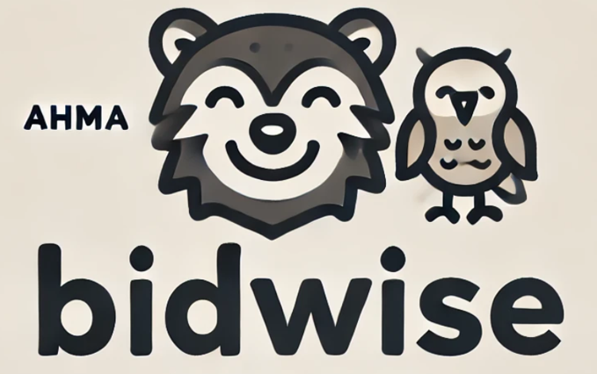 

 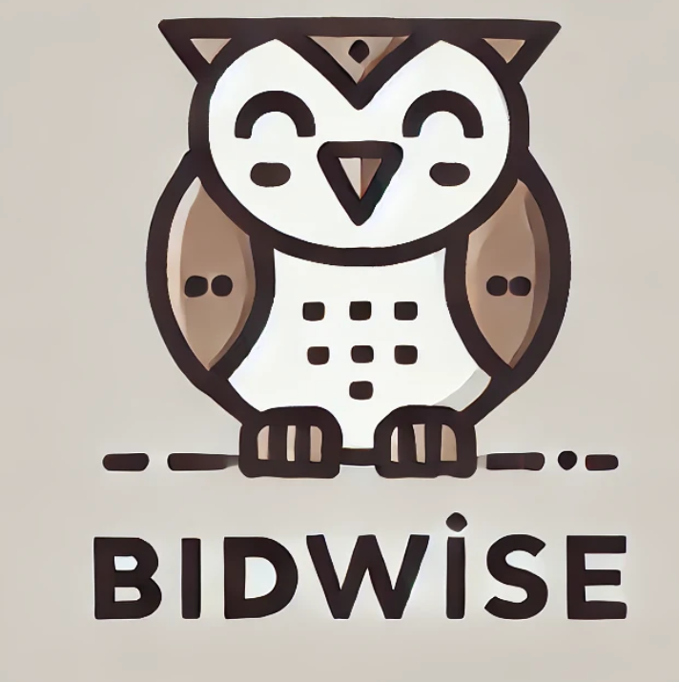

FINAL VERSION:

We chose the owl for the BidWise logo because it represents wisdom and insight, matching our goal to provide smart solutions. The clean design and earthy colors reflect trust, simplicity, and professionalism, making it approachable for businesses and investors.

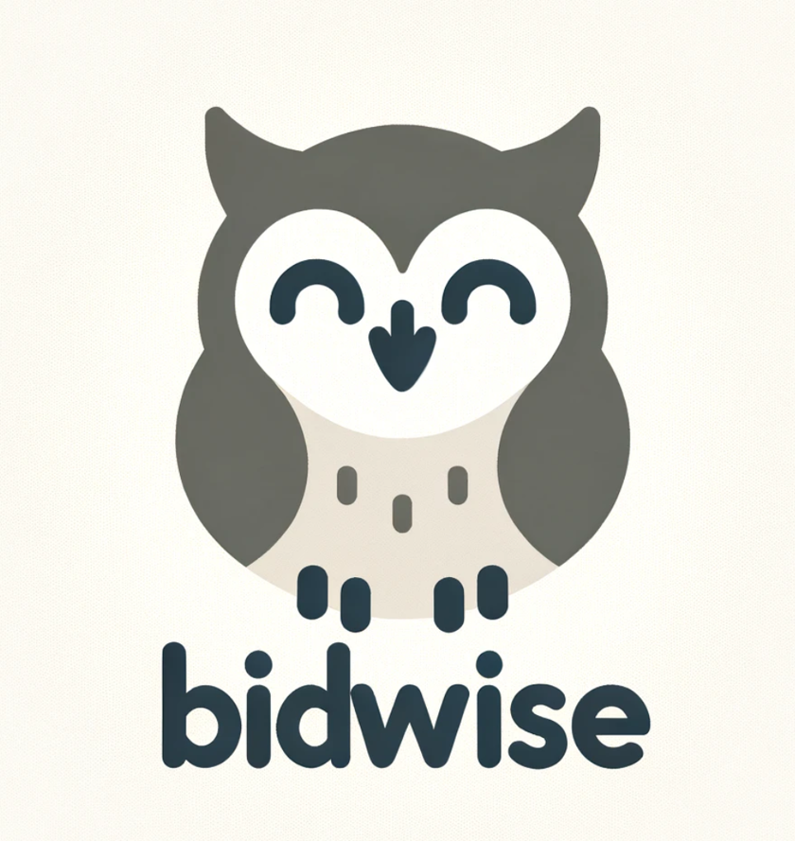

# Name development

We came up with the name BidWise by combining the idea of "bidding," which reflects the marketplace for receivables, with "wise," emphasizing smart, data-driven decisions. It’s simple, memorable, and captures the essence of what our platform offers: a smarter way to trade overdue receivables.

During the brainstorming for the name, we considered several options before settling on BidWise. Some of the alternatives included:

BidSmart: Highlighting intelligent bidding and decision-making.

TradeFlow: Emphasizing the streamlined trading process.

DebtHub: A central hub for receivable trading.

ReceivableX: Adding a modern and tech-savvy vibe to receivable trading.

SmartBidder: Focusing on making the bidding process smarter.

Ultimately, we chose BidWise because it was simple, clear, and perfectly captured the platform's focus on fast and smart trading. It also stood out as professional and easy to remember.

# More infomation

Read more in our [GitHub page](https://github.com/TahvoTech/COMP.SE.330-Lean-Startup) for BidWise!

[](https://github.com/TahvoTech/COMP.SE.330-Lean-Startup)